## 2.4.1 图像特征提取与动态街景视觉感知

城市的规划与设计笼统来说，是在平衡可见事物（建筑、道路、植被、车辆…）与不可见事物(能量、感知、关系、结构…)，是理解不可见来规划可见，可见事物则影射着城市的结构、肌理、物质信息流、生活方式、城市感知、自然自身运行的发展等。图像（照片，影像）是对可见事物的捕捉，是否可以从图像的信息中扑捉到不可见事物呢？目前计算机视觉的发展，可以解构图像信息，这为规划设计行业注入了新的技术手段。为方便计算机视觉的理解，可以粗略分为两个层级，一是，基于[OpenCV](https://opencv.org/)①库提供的各类算法对图像解析，计算图像处理，图像特征提取，对象检测等；二是，应用深度学习实现图像的语义分割、图像特征迁移、对抗生成等。这些方法对规划行业有着重要的影响，百度、Google的街景图像，及无人驾驶项目带来的大量序列图像（连接有GPS，惯性测量单元IMU（Inertial Measurement Unit）等传感器信息数据），及社交网络的图像（通常包括GPS信息），都推动着计算机视觉在规划领域潜在的应用前景。

OpenCV是计算机视觉开源库，包括有数百种计算机视觉算法。对应的[OpenCV-Python](https://docs.opencv.org/4.x/d6/d00/tutorial_py_root.html)②库包括其核心功能、图像处理、视频分析、相机标定与三维重建、对象检测和特征提取等。

### 2.4.1.1 OpenCV读取图像与图像处理示例

OpenCV的具体内容可以查看官网手册。图像处理部分，下述代码示例了图像的读取和图像模糊、边缘检测、角点检测及建立图像金字塔显示等内容，粗略了解图像处理的一些基本内容。对于该部分也可以结合到卷积部分的知识阐述。其中建立图像金字塔显示对于应用GIS等平台处理地理信息图像时并不陌生，大数据量的遥感影像显示并不是一次加载所有单元数据，而是根据所需要的显示效果，建立一系列不同分辨率的图像，这些图像叠合在一起，最高分辨率的位于底层，最低的则位于顶部，类似金字塔，因此图像的集合被称为图像金字塔，从而提升了显示的速度。

角点检测时，为了能够清晰显示主要的角点内容，通过放大菱角标记和定义显示阈值实现。注意角点检测在官方的归类中是将其纳入到特征提取的部分。

注意，cv2即OpenCV-Python库通常需要安装pip install opencv-python 和 pip install opencv-contrib-python。

import cv2 as cv   
import sys  
  
img_1_fp=r'./data/cv_IMG_0405.JPG'  
img_2_fp=r'./data/cv_IMG_0407.JPG'  
  
img_1=cv.imread(cv.samples.findFile(img_1_fp))  
img_2=cv.imread(cv.samples.findFile(img_2_fp))  
  
if img_1 is None:  
 sys.exit("could not read the image")  
cv.imshow("display window", img_1) # 图像将在一个新打开的窗口中显示  
k=cv.waitKey(0)

使用cv.imshow会打开一个新的窗口显示图像内容。因为cv.imread读取图像为数组格式，因此可以使用matplotlib库打印，只是需要注意，OpenCV读取的图像为BGR，需要将其转换为RGB，否则显示的颜色会不正确。

import matplotlib.pyplot as plt  
import numpy as np  
import copy  
fig, axs=plt.subplots(ncols=2,nrows=3,figsize =(30, 15))  
  
# 01-原始图像  
img_2_RGB=cv.cvtColor(img_2,cv.COLOR_BGR2RGB) # 注意OpenCV读取图像，其格式为BGR，需要将其调整为RGB再用matplotlib库打印  
axs[0][0].imshow(img_2_RGB)  
axs[0][0].set_title("original image-shape=(684, 1920, 3)")  
  
# 02-averaging 均值模糊  
axs[0][1].imshow(cv.blur(img_2_RGB,(15,15)))  
axs[0][1].set_title("averaging blure")  
  
# 03-Canny边缘检测  
axs[1][0].imshow(cv.Canny(img_2_RGB,200,300))  
axs[1][0].set_title("Canny edge detection")  
  
# 04-Harris角点检测  
img_2_gray=np.float32(cv.cvtColor(img_2,cv.COLOR_BGR2GRAY)) # 将图像转换为灰度，为每一像素位置1个值，可理解为图像的强度(颜色，易受光照影响，难以提供关键信息，故将图像进行灰度化，同时也可以加快特征提取的速度。)，并强制转换为浮点值，用于棱角检测。  
img_2_harris=cv.cornerHarris(img_2_gray,7,5,0.04) # 哈里斯角检测器  
img_2_harris_dilate=cv.dilate(img_2_harris,np.ones((1,1))) # 放大棱角标记  
img_2_copy=copy.deepcopy(img_2_RGB)  
img_2_copy[img_2_harris_dilate>0.01*img_2_harris_dilate.max()]=[40,75,236]# 定义阈值，显示重要的棱  
axs[1][1].imshow(img_2_copy)  
axs[1][1].set_title("Harris corner detector")  
  
# 05-建立图像显示金字塔-pyrDown-1次  
axs[2][0].imshow(cv.pyrDown(img_2_RGB))  
axs[2][0].set_title("image pyramids-shape=(342, 960, 3)")  
  
# 06-建立图像显示金字塔-pyrDown-3次-pyrUp-1次  
axs[2][1].imshow(cv.pyrUp(cv.pyrDown(cv.pyrDown(cv.pyrDown(img_2_RGB)))))   
axs[2][1].set_title("image pyramids-shape=(172, 480, 3)")  
  
plt.show()

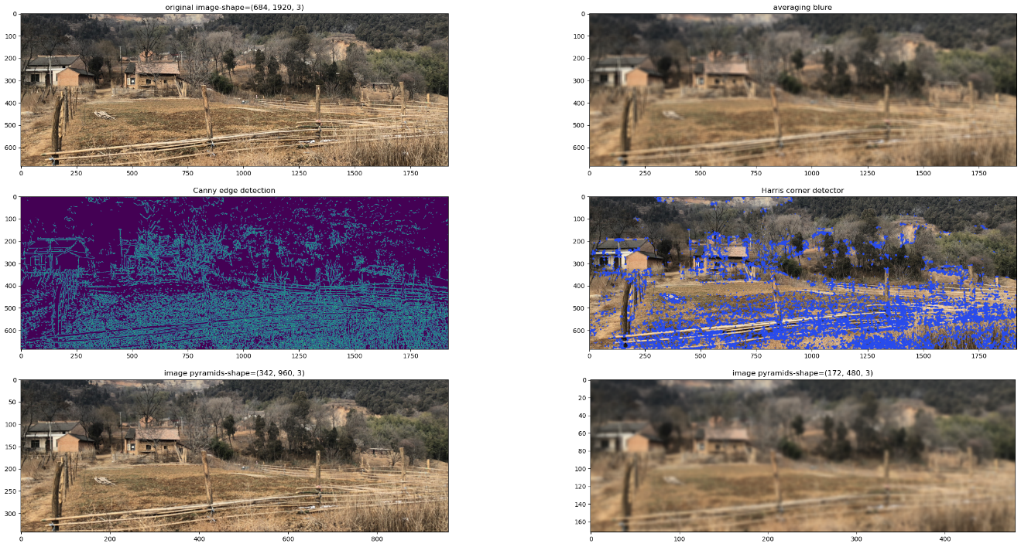

### 2.4.1.2 图像特征提取

#### 1）SIFT（Scale-Invariant Feature Transform）算法关键点阐述[1]

* A 高斯分布与高斯模糊（高斯卷积核）

高斯分布即正态分布，可以查看正态分布与概率密度函数部分，其概率密度函数为：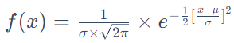，式中σ为标准差；μ为平均值； e为自然对数的底。因为使用二维高斯分布作为卷积核，中心点对应着原点，因此μ=0，公式可以简化为：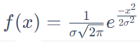，对应的2维高斯函数为：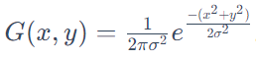。代码中的计算直接调用SciPy库，分别使用norm和 multivariate_normal方法实现1维和2维高斯函数的计算。从打印的结果查看2维的高斯分布，以中心点为最大值，向四周逐渐降低，其分布的幅度由σ控制，σ较小时，中心点最高，曲线（曲面）较陡；反之，σ值较大时，中心点较低。曲线（曲面）趋于缓和。

高斯模糊（Gaussian blur）是以二维高斯分布为卷积核（权重值）对图像（或二维数组）进行卷积操作，即卷积计算为每个像素值与周围相邻像素值的加权平均。原始像素值对应着卷积核的中心，具有最大的权重值，相邻像素随距离中心点的距离增加而降低。高斯卷积核可以在模糊的同时，较好的保留图像的边缘效果。高斯卷积核做归一化处理，确保在[0,1]区间。例如下述代码中假设了4种典型的矩阵（数组）类型，均匀型、凸性、凹型和偏斜型，以及假设高斯权重卷积核，通过计算卷积（权重加权平均）得到结果为，均匀型值为100，凸性值为138.46，凹型值为61.54，偏斜型值为107.69。均匀性为衡量的标准，可见凹凸型都较大的偏离均匀型值，而偏斜型则靠近均匀型，因此通过这个典型的案例，可以清楚的理解到高斯卷积核可以计算目标像素与周边像素值之间的差异程度。

import numpy as np  
from scipy.stats import norm  
import matplotlib.pyplot as plt  
  
fig=plt.figure(figsize=(20,9))  
ax1=fig.add_subplot(121)  
ax2=fig.add_subplot(122,projection='3d')  
  
# A-一维高斯分布（即正态分布）  
x=np.linspace(norm.ppf(0.01), norm.ppf(0.99), 100)  
for scale in np.arange(1,5,0.3):  
 ax1.plot(x, norm.pdf(x,loc=0,scale=scale),'-', lw=3, alpha=0.6, label='Sigma=%.2f'%scale) # 位置loc（平均值）和比例scale（标准差）参数  
   
# B-二维高斯分布  
from scipy.stats import multivariate_normal  
from matplotlib import cm  
x_, y=np.mgrid[-1.0:1.0:30j, -1.0:1.0:30j] # x,y=np.meshgrid(np.linspace(-1,1,10), np.linspace(-1,1,10))  
xy=np.column_stack([x_.flat, y.flat])  
  
for scale in np.arange(1,5,0.3):  
 mu=np.array([0.0, 0.0])  
 sigma=np.array([scale, scale])  
 covariance=np.diag(sigma**2)  
 z=multivariate_normal.pdf(xy, mean=mu, cov=covariance)  
 z=z.reshape(x_.shape)  
 ax2.plot_surface(x_,y,z,cmap=cm.coolwarm,alpha=0.4)  
  
ax1.legend(loc='upper left', frameon=False)  
ax1.spines['right'].set_visible(False)  
ax1.spines['top'].set_visible(False)  
ax2.view_init(20,50)  
plt.show()

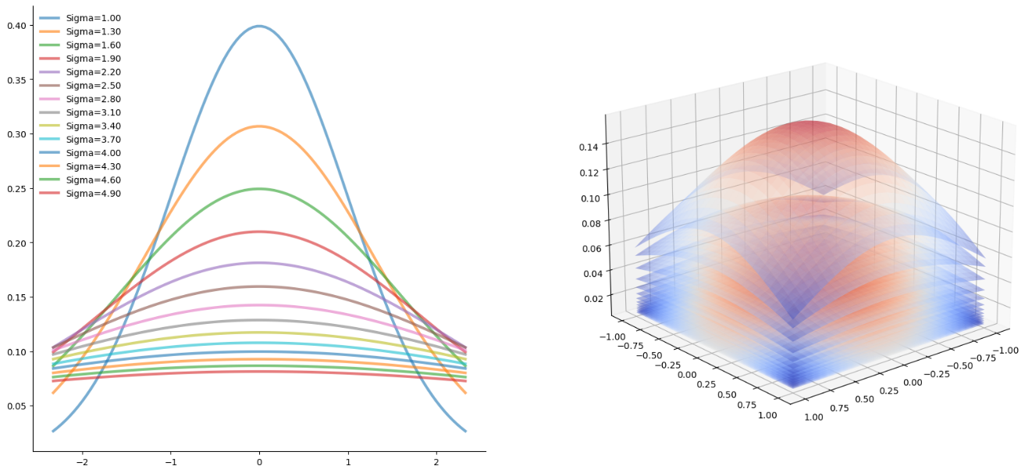

matrix_even=np.array([[100,100,100],[100,100,100],[100,100,100]]) # 均匀型  
matrix_convex=np.array([[100,100,100],[100,200,100],[100,100,100]]) # 凸型  
matrix_concave=np.array([[100,100,100],[100,0,100],[100,100,100]]) # 凹型  
matrix_skew=np.array([[200,100,100],[100,100,100],[100,100,100]]) # 偏斜型  
  
kernal=np.array([[0.1,0.1,0.1],[0.1,0.5,0.1],[0.1,0.1,0.1]])  
even_weightedAverage=np.average(matrix_even,weights=kernal)  
convex_weightedAverage=np.average(matrix_convex,weights=kernal)  
concave_weightedAverage=np.average(matrix_concave,weights=kernal)  
skew_weightedAverage=np.average(matrix_skew,weights=kernal)  
  
print("even_WA=%.2f,convex_WA=%.2f,concave_WA=%.2f,skew_WA=%.2f"%(even_weightedAverage,convex_weightedAverage,concave_weightedAverage,skew_weightedAverage))

even_WA=100.00,convex_WA=138.46,concave_WA=61.54,skew_WA=107.69

OpenCV可以增加滑动条，实时调整数据，与显示更新后的图像，方便观察参数变化对计算结果的影响。下述实现了给定卷积核大小和σ两个参数，应用OpenCV库提供的GaussianBlur函数实现图像高斯模糊的过程。

def Gaussion_blur(img_fp):   
 '''  
 function - 应用OpenCV计算高斯模糊，并给定滑动条调节参数  
   
 Params:  
 img_fp - 图像路径；string  
   
 Returns:  
 None  
 '''  
 import cv2 as cv   
   
 # 回调函数  
 def Gaussian_blur_size(GBlur_size): # 高斯核(卷积核大小)，值越大，图像越模糊  
 global KSIZE   
 KSIZE = GBlur_size * 2 +3  
 print("changes in kernel size:",KSIZE, SIGMA)  
 dst = cv.GaussianBlur(img, (KSIZE,KSIZE), SIGMA, KSIZE)   
 cv.imshow(window_name,dst)  
  
 def Gaussian_blur_Sigma(GBlur_sigma): # σ(sigma)设置，值越大，图像越模糊  
 global SIGMA  
 SIGMA = GBlur_sigma/10.0  
 print ("changes in sigma:",KSIZE, SIGMA)  
 dst = cv.GaussianBlur(img, (KSIZE,KSIZE), SIGMA, KSIZE)   
 cv.imshow(window_name,dst)  
  
 # 全局变量  
 GBlur_size = 1  
 GBlur_sigma = 15  
   
 global KSIZE   
 global SIGMA  
 KSIZE = 1  
 SIGMA = 15  
 max_value = 300  
 max_type = 6  
 window_name = "Gaussian Blur"  
 trackbar_size = "Size*2+3"  
 trackbar_sigema = "Sigma/10"  
  
 # 读入图片，模式为灰度图，创建窗口  
 img= cv.imread(img_fp,0)  
 cv.namedWindow(window_name)  
   
 # 创建滑动条  
 cv.createTrackbar( trackbar_size, window_name,GBlur_size, max_type,Gaussian_blur_size)  
 cv.createTrackbar( trackbar_sigema, window_name,GBlur_sigma, max_value, Gaussian_blur_Sigma)   
   
 # 初始化  
 Gaussian_blur_size(GBlur_size)  
 Gaussian_blur_Sigma(GBlur_sigma)   
  
 if cv.waitKey(0) == 27:   
 cv.destroyAllWindows()   
  
img_2_fp=r'./data/cv_IMG_0407.JPG'  
Gaussion_blur(img_2_fp)

changes in kernel size: 5 15  
changes in sigma: 5 1.5  
changes in kernel size: 5 1.5  
changes in sigma: 5 1.5

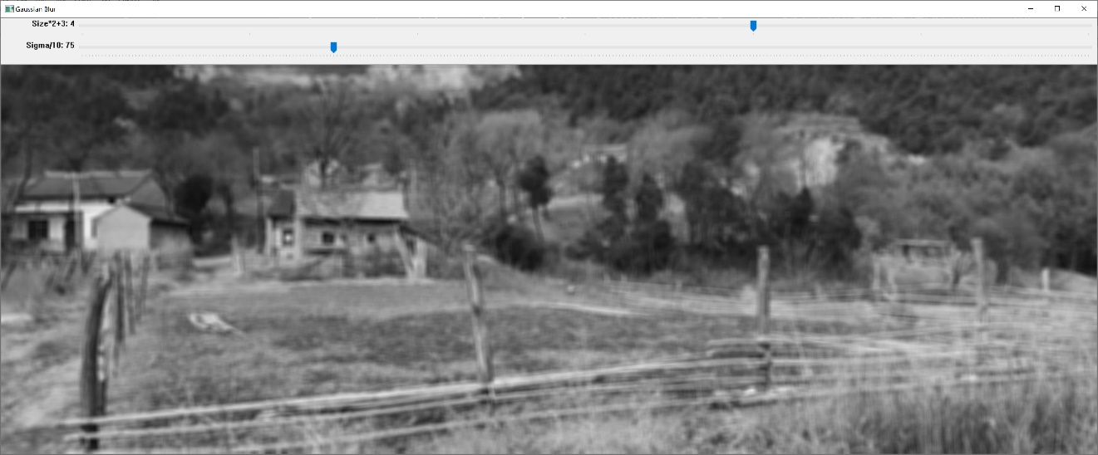

* B 尺度空间（scale space）与高斯差分金字塔

从高斯分布（函数）到高斯模糊可知，在固定卷积核大小时，不同的σ值，因为产生权重值的分布陡峭程度不同，图像的模糊程度会对应变化。可理解为基于变化权重值的图像拉伸，从图像整体上来讲就是各个像素值与各周边像素值的差异程度。而σ值的变化带来差异程度分布即加权均值分布的差异，这个差异变化是固定卷积核大小下尺度空间的纵深向空间。当σ设置值较大时，差异程度分布趋向于均值，反映图像的概貌特征；设置较小时，差异程度分布明显，强化了目标像素与周边像素的差异性，对应于图像的细节特征。如果对图像连续降采样，每一个降采样都是前一图像的1/4，即长宽分别缩小一倍，这一连续降采样获得的多个图像就是尺度空间的水平向空间。降采样类似于遥感影像的空间分辨率，如果分辨率为1m，即遥感影像的每一单元（cell）大小为1m，可以分辨出建筑、道路、车辆，甚至行人的信息，但是如果降采样到空间分辨率为30m时，则较大的建筑，农田，林地可以分辨出，但是小于30m的建筑，车辆和行人等信息是不能分辨的。降采样的水平向空间实际上反映了不同大小地物存在的尺度，或理解为不同的尺度反映不同大小的地物信息，结合到图像上，即为图像的不同内容存在不同的水平向尺度。将上述阐述对应到D.Lowe[1]的论文明确其相应的定义，可以确定降采样的水平向空间为八度（octave）的定义，每一个八度即为连续降采样的图像之一，可以称之为组。而对每一降采样（octave）图像进行高斯卷积核计算，，这些不同参数下的卷积结果即为每一八度的层。组（降采样-八度，octave）反映图像内容（地物）的水平向尺度（空间分辨率），构成了高斯金字塔的尺度空间）。

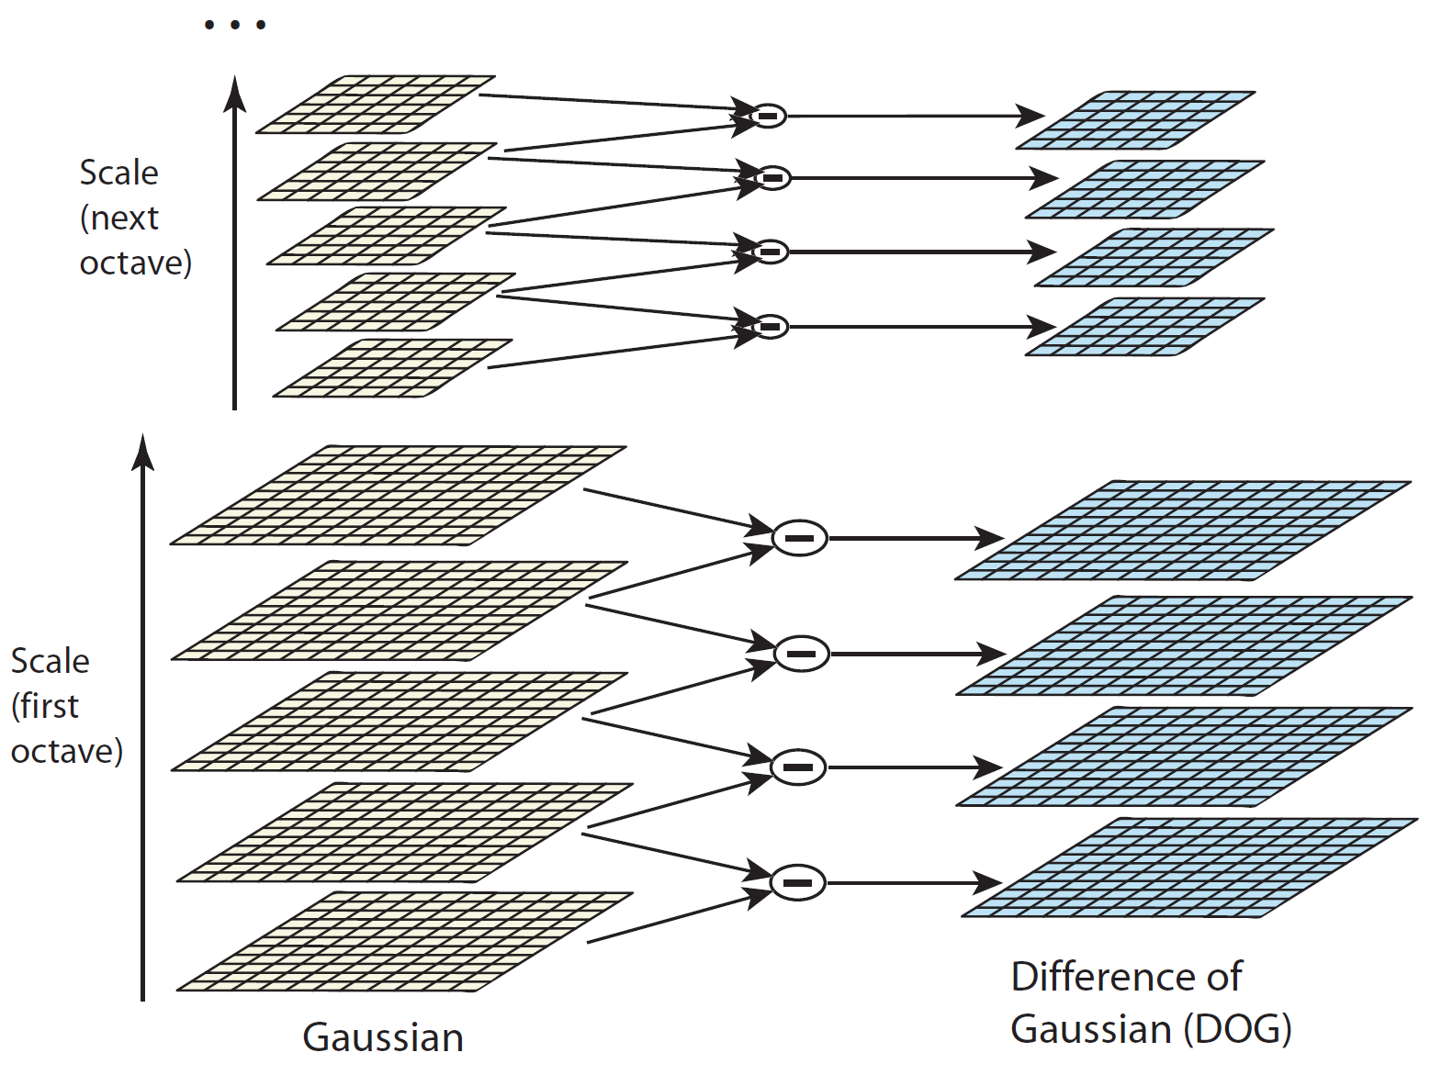

D.Lowe将图像的尺度空间定义为L(x,y,σ)=G(x,y,σ)∗I(x,y)，式中G(x,y,σ)为变化尺度的高斯函数(2维)， I(x,y)为原图像（像素位置），∗表示卷积运算。

为在连续的尺度空间下检测到特征点，建立高斯差分金字塔（difference-of-Gaussian ，DOG），其高斯差分算子为D(x,y,σ)=(G(x,y,kσ)−G(x,y,σ))∗I(x,y)=L(x,y,kσ)−L(x,y,σ)，即在左图每一组（octave）下每相邻的两层图像相减得到右侧的图像。层之间的差值可以理解为相邻σ值的变化反映目标像素与周围像素差异程度表现在层之间的变化程度。而层间较大的程度变化代表着尺度空间纵深向目标像素点与周边像素点差异程度表现最为突出所在的层，即该层反映了目标像素的特征。如果同时考虑到水平向空间，假设5m的空间分辨率为车辆的水平向尺度空间的界定边界（一个组），即如果大于5m，车辆信息被淹没在更大尺度的地物中，例如车辆被分配到绿地空间里。要想在5m的水平向尺度下，将车辆提取出来，必须比较车辆所在像素与周边像素的差异，如果差异程度较高则可以提取，但是必须寻找到体现差异程度最大的纵深向尺度空间的层。

* C 空间关键点（极值点）检测

已获得DOG，为寻找极值点，需要比较中间的检测点与其同纵深向尺度空间的8个相邻点和上下相邻纵深向尺度层的18个点，共26个点进行比较。每组中的纵深向尺度空间，设置连续的σ值，可以产生无数连续的层，对于一个目标像素而言，就是需要不断比较连续的DOG中的相邻层，从而获得无数个离散的局部的极值点，离散的空间极值点并不是真正的极值点，因此可以对尺度空间DOG函数通过泰勒展开式（具体可参看微积分部分的泰勒展开式）拟合函数（二次方程）为：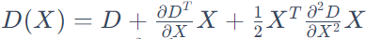，其中X=(x,y,σ)T。对X求导，并令方程等于0，求得极值点（关键点）的位置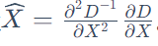。

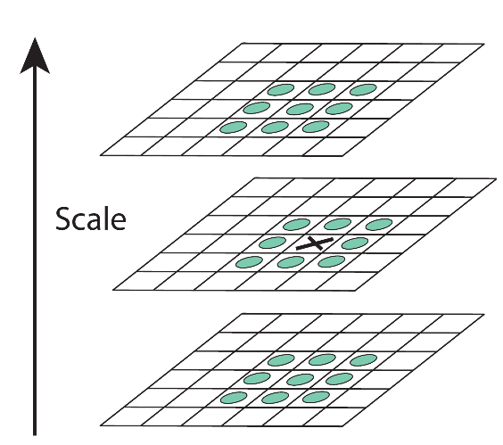

* D 关键点方向（用一组向量描述关键点，特征向量）

计算像素点的幅度（梯度大小，gradient magnitude）  
m(x,y)和方向(orientation)θ(x,y)，使用像素的位置差异预先计算，例如像素的位置标识：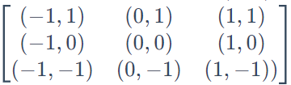 ​​，以关键点为中心，以3×1.5σ为半径的同一纵向尺度空间的邻域内计算，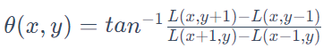​， L为关键点所在的尺度空间值，即对应的高斯模糊图像。完成关键点的梯度大小和方向计算后，统计频数，将360度的方向划分为36个等分（bin），频数最大值代表关键点的主方向。

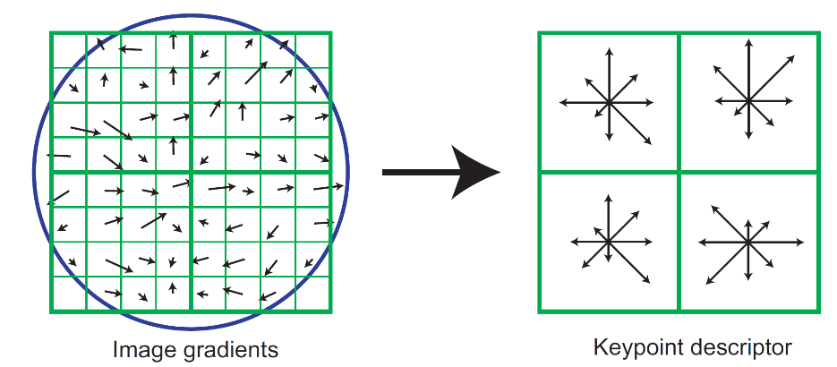

在关键点位置周围区域内（指定半径的圆形区域，或关键点周围16×1616×16个像素点），首先计算每个图像样本点的梯度大小和方向（高斯卷积核加权），创建关键点描述子（符）。然后这些样本累积成4×44×4次区域内方向直方图（每个关键点有16个子块（sub-block），即有16个直方图，每个块为4×44×4的像素点，上图仅以8×88×8邻域为例），每个箭头的长度对应区域内该方向附近的梯度大小之和，将所有方向特征相邻连接起来，够成16×8=12816×8=128维的特征向量。至此，每个关键点有三个信息 (x,y,σ,θ,magnitude,region)，即位置，纵深向空间尺度、方向和大小，及邻域。

使用OpenCV的SIFT_create()方法实现尺度不变特征转换，所返回的关键点信息对应位置点坐标、邻域（直径），水平向空间尺度（即octave）、梯度大小（响应程度）和方向，对图像分类（-1为未设置）。OpenCV的SIFT计算配置邻域大小同样为16×16，划分为4×44×4大小的16个子块，总共128份（bin）。

def SIFT_detection(img_fp,save=False):   
 '''  
 function - 尺度不变特征变换(scale invariant feature transform，SIFT)特征点检测  
   
 Params:  
 img_fp - 图像文件路径；string  
 save- 是否保存特征结果图像。 The default is False；bool  
   
 Returns:  
 None  
 '''  
 import cv2 as cv  
 import numpy as np  
 import matplotlib.pyplot as plt   
   
 img=cv.imread(img_fp)  
 img_gray=cv.cvtColor(img,cv.COLOR_BGR2GRAY)  
 sift=cv.SIFT_create() # SIFT特征实例化 cv.xfeatures2d.SIFT_create()  
 key_points=sift.detect(img_gray,None) # 提取SIFT特征关键点detector  
   
 # 示例打印关键点数据  
 for k in key_points[:5]:  
 print("关键点点坐标:%s,直径:%.3f,金字塔层:%d,响应程度:%.3f,分类:%d,方向:%d"%(k.pt,k.size,k.octave,k.response,k.class_id,k.angle))  
 """  
 关键点信息包含：  
 k.pt关键点点的坐标(图像像素位置)  
 k.size该点范围的大小（直径）  
 k.octave从高斯金字塔的哪一层提取得到的数据  
 k.response响应程度，代表该点强壮大小，即角点的程度。角点：极值点，某方面属性特别突出的点(最大或最小)。  
 k.class_id对图像进行分类时，可以用class_id对每个特征点进行区分，未设置时为-1  
 k.angle角度，关键点的方向。SIFT算法通过对邻域做梯度运算，求得该方向。-1为初始值   
 """  
 print("_"*50)   
 descriptor=sift.compute(img_gray,key_points) # 提取SIFT调整描述子-descriptor，返回的列表长度为2，第1组数据为关键点，第2组数据为描述子(关键点周围对其有贡献的像素点)  
 print("key_points数据类型:%s,descriptor数据类型:%s"%(type(key_points),type(descriptor)))  
 print("关键点：")  
 print(descriptor[0][:1]) # 关键点  
 print("描述子：")  
 print(descriptor[1][:1]) # 描述子  
 print("描述子 shape:",descriptor[1].shape)   
   
 cv.drawKeypoints(img,key_points,img,flags=cv.DRAW_MATCHES_FLAGS_DRAW_RICH_KEYPOINTS)   
   
 if save:  
 cv.imshow('sift features',img)  
 cv.imwrite('./data/sift_features.jpg',img) # 保存图像  
 cv.waitKey()  
 else:   
 fig, ax=plt.subplots(figsize=(30,15))  
 ax.imshow(cv.cvtColor(img,cv.COLOR_BGR2RGB) )  
 plt.show()   
  
SIFT_detection(img_fp=img_2_fp)

关键点点坐标:(2.318413734436035, 498.3979187011719),直径:1.818,金字塔层:852479,响应程度:0.019,分类:-1,方向:300  
关键点点坐标:(2.7633209228515625, 405.3725891113281),直径:2.134,金字塔层:12452351,响应程度:0.015,分类:-1,方向:2  
关键点点坐标:(2.7633209228515625, 405.3725891113281),直径:2.134,金字塔层:12452351,响应程度:0.015,分类:-1,方向:155  
关键点点坐标:(2.925368547439575, 662.67041015625),直径:1.981,金字塔层:7078399,响应程度:0.017,分类:-1,方向:257  
关键点点坐标:(3.029824733734131, 606.0113525390625),直径:2.157,金字塔层:13238783,响应程度:0.042,分类:-1,方向:61  
__________________________________________________  
key_points数据类型:<class 'tuple'>,descriptor数据类型:<class 'tuple'>  
关键点：  
(< cv2.KeyPoint 00000255E1C765A0>,)  
描述子：  
[[ 0. 0. 0. 0. 0. 0. 0. 0. 0. 0. 0. 0. 0. 4.  
 14. 3. 8. 0. 0. 0. 0. 9. 43. 48. 30. 2. 0. 0.  
 0. 14. 32. 24. 12. 11. 0. 0. 8. 23. 2. 1. 129. 39.  
 0. 0. 3. 21. 81. 43. 24. 0. 1. 2. 66. 65. 129. 74.  
 8. 5. 23. 7. 27. 20. 33. 23. 42. 30. 15. 13. 10. 55.  
 37. 23. 129. 18. 1. 6. 7. 26. 55. 129. 56. 6. 4. 121.  
 129. 28. 8. 14. 1. 6. 93. 106. 60. 2. 0. 1. 129. 91.  
 20. 15. 2. 1. 12. 53. 73. 4. 1. 6. 28. 24. 47. 103.  
 4. 1. 1. 111. 129. 38. 3. 4. 3. 2. 17. 80. 55. 4.  
 0. 1.]]  
描述子 shape: (19810, 128)

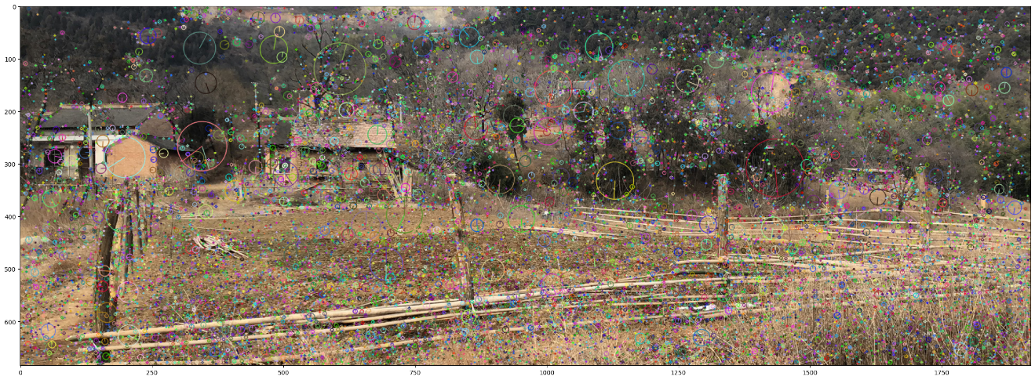

OpenCV提供有多种类型的特征检测和描述算法，如果SIFT计算速度不够快，可以尝试使用SURF（Speeded-Up Robust Features），或者BRIEF（Binary Robust Independent Elementary Feature）算法，如果需要实时性，例如机器人领域里的SLAM（simultaneous localization and mapping）配合使用，则可以应用FAST（Features from accelerated segment test）算法。下述为Star算法实现，每种算法都有各自的优缺点，需要针对分析目标进行比较确定。

def STAR_detection(img_fp,save=False):  
 '''  
 function - 使用Star特征检测器提取图像特征  
 Params:  
 img_fp - 图像文件路径   
 save- 是否保存特征结果图像。 The default is False；bool  
   
 Returns:  
 None  
 '''  
 import cv2 as cv  
 import numpy as np  
 import copy  
 import matplotlib.pyplot as plt   
   
 img=cv.imread(img_fp)  
 star=cv.xfeatures2d.StarDetector_create()   
 key_point=star.detect(img)  
 cv.drawKeypoints(img,key_point,img,flags=cv.DRAW_MATCHES_FLAGS_DRAW_RICH_KEYPOINTS)  
  
 if save:  
 cv.imshow('star features',img_copy)  
 cv.imwrite('./data/star_features.jpg',img) # 保存图像  
 cv.waitKey()  
 else:   
 fig, ax=plt.subplots(figsize=(30,15))  
 ax.imshow(cv.cvtColor(img,cv.COLOR_BGR2RGB) )  
 plt.show()   
   
STAR_detection(img_fp=img_2_fp)

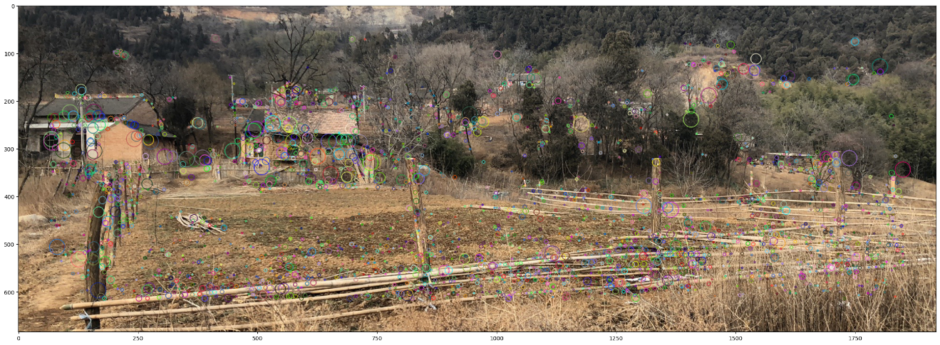

#### 2）特征匹配

通过特征检测器可以获取图像关键点的描述子，那么包含同一事物（具有同样的特征）的两幅图像就可以通过描述子匹配。[OpenCV提供了三种方式](https://docs.opencv.org/master/dc/dc3/tutorial_py_matcher.html)③，一种是基于ORB（Oriented FAST and Rotated BRIEF）描述子的蛮力匹配（Brute-Force Matching with ORB Descriptors），再者为使用SIFT描述子和比率检测蛮力匹配（Brute-Force Matching with SIFT Descriptors and Ratio Test），及基于FLANN的匹配器（FLANN based Matcher）。

注意，有些算法是已申请专利的。

def feature_matching(img_1_fp,img_2_fp,index_params=None,method='FLANN'):   
 '''  
 function - OpenCV 根据图像特征匹配图像。迁移官网的三种方法，1-ORB描述子蛮力匹配　Brute-Force Matching with ORB Descriptors；2－使用SIFT描述子和比率检测蛮力匹配 Brute-Force Matching with SIFT Descriptors and Ratio Test; 3-基于FLANN的匹配器 FLANN based Matcher  
   
 Params:  
 img_1 - 待匹配图像1路径；string  
 img_2 - 待匹配图像2路径；string  
 method - 参数为:'ORB','SIFT','FLANN'。The default is 'FLANN'；string  
   
 Returns:  
 None  
 '''  
 import numpy as np  
 import cv2 as cv  
 import matplotlib.pyplot as plt   
   
 plt.figure(figsize=(30,15))  
 img1 = cv.imread(img_1_fp,cv.IMREAD_GRAYSCALE) # queryImage  
 img2 = cv.imread(img_2_fp,cv.IMREAD_GRAYSCALE) # trainImage  
 if method=='ORB':  
 # Initiate ORB detector  
 orb = cv.ORB_create()  
 # find the keypoints and descriptors with ORB  
 kp1, des1 = orb.detectAndCompute(img1,None)  
 kp2, des2 = orb.detectAndCompute(img2,None)  
   
 # create BFMatcher object  
 bf = cv.BFMatcher(cv.NORM_HAMMING, crossCheck=True)  
 # Match descriptors.  
 matches = bf.match(des1,des2)  
 # Sort them in the order of their distance.  
 matches = sorted(matches, key = lambda x:x.distance)  
 # Draw first 10 matches.  
 img3 = cv.drawMatches(img1,kp1,img2,kp2,matches[:10],None,flags=cv.DrawMatchesFlags_NOT_DRAW_SINGLE_POINTS)  
 plt.imshow(img3),plt.show()  
   
 if method=='SIFT':   
 # Initiate SIFT detector  
 sift = cv.SIFT_create()  
 # find the keypoints and descriptors with SIFT  
 kp1, des1 = sift.detectAndCompute(img1,None)  
 kp2, des2 = sift.detectAndCompute(img2,None)  
 # BFMatcher with default params  
 bf = cv.BFMatcher()  
 matches = bf.knnMatch(des1,des2,k=2)  
 # Apply ratio test  
 good = []  
 for m,n in matches:  
 if m.distance < 0.75*n.distance:  
 good.append([m])  
 # cv.drawMatchesKnn expects list of lists as matches.  
 img3 = cv.drawMatchesKnn(img1,kp1,img2,kp2,good[0:int(1*len(good)):int(0.1*len(good))],None,flags=cv.DrawMatchesFlags_NOT_DRAW_SINGLE_POINTS)  
 plt.imshow(img3),plt.show()   
   
 if method=='FLANN':  
 # Initiate SIFT detector  
 sift = cv.SIFT_create()  
 # find the keypoints and descriptors with SIFT  
 kp1, des1 = sift.detectAndCompute(img1,None)  
 kp2, des2 = sift.detectAndCompute(img2,None)  
 search_params = dict(checks=50) # or pass empty dictionary  
 flann = cv.FlannBasedMatcher(index_params,search_params)  
 matches = flann.knnMatch(des1,des2,k=2)  
 # Need to draw only good matches, so create a mask  
 matchesMask = [[0,0] for i in range(len(matches))]  
 # ratio test as per Lowe's paper  
 for i,(m,n) in enumerate(matches):  
 if m.distance < 0.7*n.distance:  
 matchesMask[i]=[1,0]  
 draw_params = dict(matchColor = (0,255,0),  
 singlePointColor = (255,0,0),  
 matchesMask = matchesMask,  
 flags = cv.DrawMatchesFlags_DEFAULT)  
 img3 = cv.drawMatchesKnn(img1,kp1,img2,kp2,matches,None,**draw_params)  
 plt.imshow(img3,),plt.show()  
   
feature_matching(img_1_fp,img_2_fp,method='ORB',)

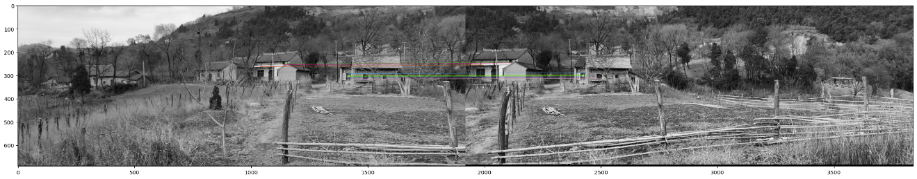

feature_matching(img_1_fp,img_2_fp,method='SIFT',)

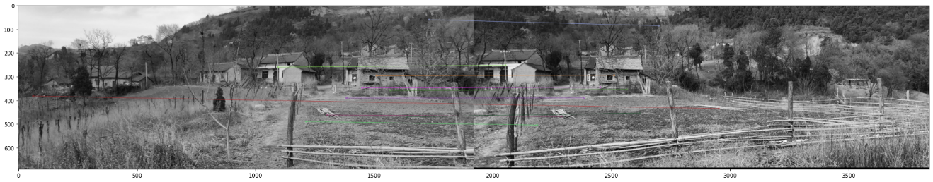

# FLANN parameters  
FLANN_INDEX_KDTREE = 1  
index_params = dict(algorithm = FLANN_INDEX_KDTREE, trees = 5)   
feature_matching(img_1_fp,img_2_fp,index_params=index_params,method='FLANN',)

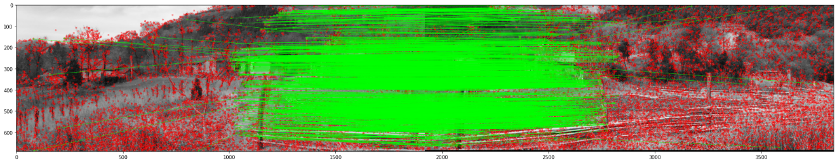

### 2.4.1.3 动态街景视觉感知

上述解释尺度空间是从算法数理逻辑层面进行的解释，如果从感性上来理解，不同尺度的图像，可以近似理解为人眼观察事物从远及近的过程，这个过程中可以认为尺度空间满足视觉不变性，即图像的分析不受图像灰度、对比度的影响，并满足平移不变性、尺度不变性、欧几里得不变性和仿射不变性。因此可以借助计算机视觉分析技术来分析研究城市街道景观的感知变化。为了保持街道景观分析数据的统一性，使用KITTI数据，这样可以保持图像的连续性，拍摄高度及视角的不变性，提高数据分析结果的可靠性。

#### 1）[The KITTI Vision Benchmark Suite](http://www.cvlibs.net/datasets/kitti/index.php)④

KITTI数据集是用于无人驾驶场景下计算机视觉算法评测数据集，连续记录有车行路线下的连续城市景观图像，及GPS定位等信息。在这里并不是用KITTI数据集研究无人驾驶，但是无人驾驶项目可以为城市规划带来用于研究城市的数据。随着无人驾驶技术的发展，及实际应用的推广，该部分的数据信息量将会成倍的增加。此次实验使用[2011_09_29_drive_0071 (4.1 GB)](http://www.cvlibs.net/datasets/kitti/raw_data.php)⑤标识数据，为城市内的街巷空间。

查看“oxts/dataformat.txt”文件，可以获知“oxts/data”下文件的数据格式，信息罗列如下：

| Column1 | Column2 |
| --- | --- |
| lat | latitude of the oxts-unit (deg) |
| lon | longitude of the oxts-unit (deg) |
| alt | altitude of the oxts-unit (m) |
| roll | roll angle (rad), 0 = level, positive = left side up, range: -pi .. +pi |
| pitch | pitch angle (rad), 0 = level, positive = front down, range: -pi/2 .. +pi/2 |
| yaw | heading (rad), 0 = east, positive = counter clockwise, range: -pi .. +pi |
| vn | velocity towards north (m/s) |
| ve | velocity towards east (m/s) |
| vf | forward velocity, i.e. parallel to earth-surface (m/s) |
| vl | leftward velocity, i.e. parallel to earth-surface (m/s) |
| vu | upward velocity, i.e. perpendicular to earth-surface (m/s) |
| ax | acceleration in x, i.e. in direction of vehicle front (m/s^2) |
| ay | acceleration in y, i.e. in direction of vehicle left (m/s^2) |
| ay | acceleration in z, i.e. in direction of vehicle top (m/s^2) |
| af | forward acceleration (m/s^2) |
| al | leftward acceleration (m/s^2) |
| au | upward acceleration (m/s^2) |
| wx | angular rate around x (rad/s) |
| wy | angular rate around y (rad/s) |
| wz | angular rate around z (rad/s) |
| wf | angular rate around forward axis (rad/s) |
| wl | angular rate around leftward axis (rad/s) |
| wu | angular rate around upward axis (rad/s) |
| pos_accuracy | velocity accuracy (north/east in m) |
| vel_accuracy | velocity accuracy (north/east in m/s) |
| navstat | navigation status (see navstat_to_string) |
| numsats | number of satellites tracked by primary GPS receiver |
| posmode | position mode of primary GPS receiver (see gps_mode_to_string) |
| velmode | velocity mode of primary GPS receiver (see gps_mode_to_string) |
| orimode | orientation mode of primary GPS receiver (see gps_mode_to_string) |
|  |  |

@ARTICLE{Geiger2013IJRR, author = {Andreas Geiger and Philip Lenz and Christoph Stiller and Raquel Urtasun}, title = {Vision meets Robotics: The KITTI Dataset}, journal = {International Journal of Robotics Research (IJRR)}, year = {2013} }

def KITTI_info(KITTI_info_fp,timestamps_fp):  
 '''  
 function - 读取KITTI文件信息，1-包括经纬度，惯性导航系统信息等的.txt文件，2-包含时间戳的.txt文件  
   
 Params:  
 KITTI_info_fp - 数据文件路径；string  
 timestamps_fp - 时间戳文件路径；string  
   
 Returns:  
 drive_info - 返回数据；DataFrame  
 '''  
 import pandas as pd  
 import util_misc  
 import os   
  
 drive_fp=util_misc.filePath_extraction(KITTI_info_fp,['txt'])  
 '''展平列表函数'''  
 flatten_lst=lambda lst: [m for n_lst in lst for m in flatten_lst(n_lst)] if type(lst) is list else [lst]  
 drive_fp_list=flatten_lst([[os.path.join(k,f) for f in drive_fp[k]] for k,v in drive_fp.items()])  
  
 columns=["lat","lon","alt","roll","pitch","yaw","vn","ve","vf","vl","vu","ax","ay","ay","af","al","au","wx","wy","wz","wf","wl","wu","pos_accuracy","vel_accuracy","navstat","numsats","posmode","velmode","orimode"]  
 drive_info=pd.concat([pd.read_csv(item,delimiter=' ',header=None) for item in drive_fp_list],axis=0)  
 drive_info.columns=columns  
 drive_info=drive_info.reset_index()  
   
 timestamps=pd.read_csv(timestamps_fp,header=None)  
 timestamps.columns=['timestamps_']  
 drive_info=pd.concat([drive_info,timestamps],axis=1,sort=False)  
 #drive_29_0071_info.index=pd.to_datetime(drive_29_0071_info["timestamps_"]) #用时间戳作为行(row)索引  
 return drive_info  
  
import util_misc  
KITTI_info_fp=r'F:\data\2011_09_29_drive_0071_sync\oxts\data'  
timestamps_fp=r'F:\data\2011_09_29_drive_0071_sync\image_03\timestamps.txt'  
drive_29_0071_info=KITTI_info(KITTI_info_fp,timestamps_fp)  
util_misc.print_html(drive_29_0071_info)

|  | **index** | **lat** | **lon** | **alt** | **roll** | **pitch** | **yaw** | **vn** | **ve** | **vf** | **vl** | **vu** | **ax** | **ay** | **ay** | **af** | **al** | **au** | **wx** | **wy** | **wz** | **wf** | **wl** | **wu** | **pos_accuracy** | **vel_accuracy** | **navstat** | **numsats** | **posmode** | **velmode** | **orimode** | **timestamps_** |
| --- | --- | --- | --- | --- | --- | --- | --- | --- | --- | --- | --- | --- | --- | --- | --- | --- | --- | --- | --- | --- | --- | --- | --- | --- | --- | --- | --- | --- | --- | --- | --- | --- |
| **0** | 0 | 49.008650 | 8.398092 | 112.923836 | 0.028517 | 0.033114 | 2.638139 | 0.245442 | -0.441073 | 0.504768 | 0.001155 | -0.027488 | 0.358166 | 0.252806 | 9.862328 | 0.685092 | -0.030191 | 9.848229 | -0.004234 | 0.000159 | 0.039881 | -0.002911 | -0.000984 | 0.039986 | 0.265887 | 0.031113 | 4.0 | 10.0 | 4.0 | 4.0 | 6.0 | 2011-09-29 13:54:59.990872576 |
| **1** | 0 | 49.008777 | 8.397611 | 112.555534 | 0.024840 | 0.020511 | 2.685955 | 1.551137 | -3.509360 | 3.833920 | -0.150608 | 0.044185 | -0.359069 | 0.360933 | 9.669620 | -0.185192 | 0.114979 | 9.680759 | -0.010214 | 0.044176 | -0.004485 | -0.010270 | 0.044276 | -0.003153 | 0.592571 | 0.102616 | 4.0 | 6.0 | 4.0 | 0.0 | 0.0 | 2011-09-29 13:55:00.094612992 |
| **2** | 0 | 49.009162 | 8.396541 | 111.875397 | 0.053510 | 0.009328 | 2.637656 | 1.450795 | -2.087462 | 2.529031 | 0.257516 | -0.026326 | -0.670685 | 0.534725 | 9.727524 | -0.576963 | 0.011668 | 9.748230 | -0.003644 | -0.003258 | 0.034353 | -0.003317 | -0.005097 | 0.034162 | 5.410355 | 0.436904 | 4.0 | 5.0 | 4.0 | 0.0 | 0.0 | 2011-09-29 13:55:00.198486528 |
| **3** | 0 | 49.008962 | 8.397075 | 112.193260 | 0.034518 | 0.016115 | 2.720819 | 0.433817 | -0.590212 | 0.715724 | 0.155884 | -0.015158 | -0.415889 | 0.271292 | 9.810824 | -0.258599 | -0.064932 | 9.819755 | 0.004917 | 0.000819 | -0.023691 | 0.004537 | 0.001629 | -0.023725 | 1.296095 | 0.160181 | 4.0 | 3.0 | 0.0 | 0.0 | 0.0 | 2011-09-29 13:55:00.302340864 |
| **4** | 0 | 49.009505 | 8.395251 | 116.018288 | 0.027009 | 0.009783 | 2.682120 | -0.030187 | -0.021443 | 0.005835 | -0.036565 | 0.034227 | -0.026252 | 0.263014 | 9.757520 | 0.070789 | -0.002531 | 9.760851 | -0.001289 | -0.001011 | -0.001923 | -0.001308 | -0.000959 | -0.001937 | 1.212669 | 0.103966 | 4.0 | 5.0 | 5.0 | 5.0 | 0.0 | 2011-09-29 13:55:00.406079232 |

通过提取的数据，应用Plotly库打印包含地图信息的图表，观察数据在现实世界里具体的位置。

def plotly_scatterMapbox(df,**kwargs):  
 '''  
 function - 使用plotly的go.Scattermapbox方法，在地图上显示点及其连线，坐标为经纬度  
   
 Paras:  
 df - DataFrame格式数据，含经纬度；DataFrame  
 field - 'lon':df的longitude列名，'lat'：为df的latitude列名，'center_lon':地图显示中心精经度定位，"center_lat":地图显示中心维度定位，"zoom"：为地图缩放；string  
 '''  
 import pandas as pd  
 import plotly.graph_objects as go   
   
 field={'lon':'lon','lat':'lat',"center_lon":8.398104,"center_lat":49.008645,"zoom":16}  
 field.update(kwargs)   
   
 fig=go.Figure(go.Scattermapbox(mode="markers",lat=df[field['lat']], lon=df[field['lon']],marker={'size': 10})) #亦可以选择列，通过size=""配置增加显示信息 ;mode="markers+lines"  
 fig.update_layout(  
 margin ={'l':0,'t':0,'b':0,'r':0},  
 mapbox = {  
 'center': {'lon': 10, 'lat': 10},  
 'style': "stamen-terrain",  
 'center': {'lon': field['center_lon'], 'lat':field['center_lat']},  
 'zoom': 16})   
 fig.show()  
   
drive_29_0071_info.sort_values(by="timestamps_",inplace=True)   
#print(drive_29_0071_info["timestamps_"].head(50))  
plotly_scatterMapbox(drive_29_0071_info)

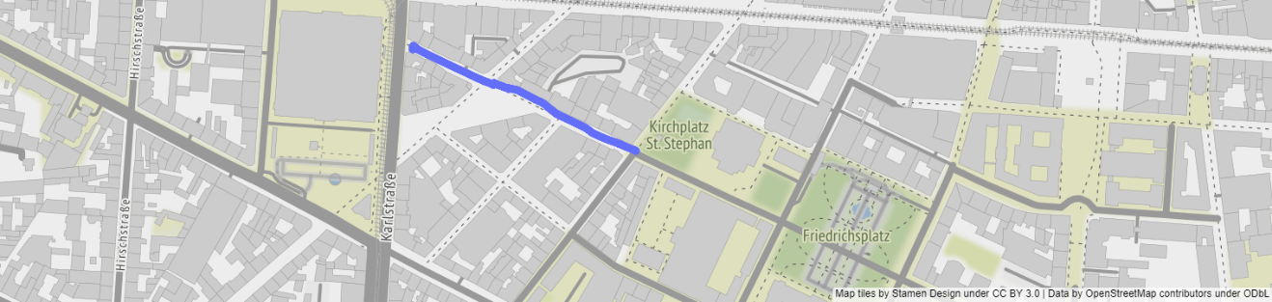

import os  
drive_29_0071_img_fp=util_misc.filePath_extraction(r'F:\data\2011_09_29_drive_0071_sync\image_03\data',['png'])  
drive_29_0071_img_fp_list=util_misc.flatten_lst([[os.path.join(k,f) for f in drive_29_0071_img_fp[k]] for k,v in drive_29_0071_img_fp.items()])  
drive_29_0071_img_fp_list.sort()

import matplotlib.pyplot as plt  
import matplotlib.animation as animation  
import matplotlib.image as mpimg  
from IPython.display import HTML  
  
fig=plt.figure(figsize=(20,10))  
ims=[[plt.imshow(mpimg.imread(f),animated=True)] for f in drive_29_0071_img_fp_list[:200]]  
print("finished reading the imgs.")  
  
ani=animation.ArtistAnimation(fig, ims, interval=100, blit=True,repeat_delay=1000) #interval=50  
#ani.save(r'./imgs/drive_29_0071_imgs.mp4')  
HTML(ani.to_html5_video())

finished reading the imgs.

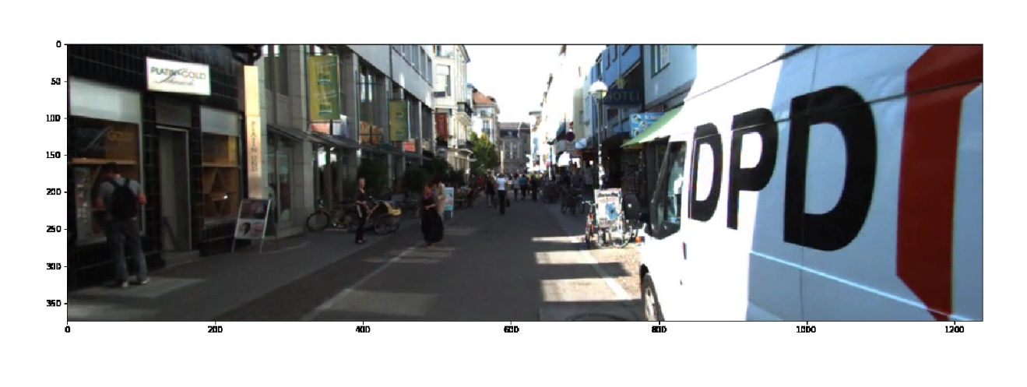

#### 2）动态街景视觉感知

图像匹配可以返回两幅图像中特征点基本相似的关键点。对于无人驾驶拍摄的连续影像而言，假设确定一个固定位置，即选择该位置上的一张影像，将其分别与之后的所有影像进行图像匹配，返回关键点，计算每一对的特征点匹配数量。这个特征点匹配数量的变化体现了当前位置的图像与之后顺序影像相似的程度。因为后一帧（后一位置）影像包含前一影像的一部分，当距离越近，两者匹配返回的特征点匹配数量越多；反之，离当前位置越远，匹配的数量越少，而且这个过程基本上是逐渐减少的。因此可以由上述计算推测一条街道视觉感知变化的情况，找到感知消失的距离；同时，也可以比较不同街道感知变化的差异；甚至，可以比较不同街道感知的相似度。

代码实现上主要包括三个部分，第一个是定义批量特征提取及返回匹配点数量的类dynamicStreetView_visualPerception；二是匹配点数量是随距离增加而逐渐降低的，需要找到降低后，基本不再变化的位置点，即感知消失的位置，定义类movingAverage_inflection；最后计算这个感知消失的距离，定义函数vanishing_position_length()。

* A - 返回特征匹配点数量

返回特征点匹配数量的类，是使用Star方法提取关键点，这个方法可以降低使用SIFT产生的噪音；然后再用SIFT根据Star提取的关键点来返回描述子；最后利用描述子进行图像匹配，返回特征点匹配的数量。

class DynamicStreetView_visualPerception:  
 '''  
 class - 应用Star提取图像关键点，结合SIFT获得描述子，根据特征匹配分析特征变化（视觉感知变化），即动态街景视觉感知  
   
 Params:  
 imgs_fp - 图像路径列表；list(string)  
 knnMatch_ratio - 图像匹配比例，默认为0.75；float  
 '''  
 def __init__(self,imgs_fp,knnMatch_ratio=0.75):  
 self.knnMatch_ratio=knnMatch_ratio  
 self.imgs_fp=imgs_fp  
   
 def kp_descriptor(self,img_fp):   
 '''  
 function - 提取关键点和获取描述子  
 '''  
 import cv2 as cv  
   
 img=cv.imread(img_fp)  
 star_detector=cv.xfeatures2d.StarDetector_create()   
 key_points=star_detector.detect(img) # 应用处理Star特征检测相关函数，返回检测出的特征关键点  
 img_gray=cv.cvtColor(img,cv.COLOR_BGR2GRAY) # 将图像转为灰度  
 kp,des=cv.xfeatures2d.SIFT_create().compute(img_gray, key_points) # SIFT特征提取器提取特征  
 return kp,des   
   
 def feature_matching(self,des_1,des_2,kp_1=None,kp_2=None):   
 '''  
 function - 图像匹配  
 '''  
 import cv2 as cv  
   
 bf=cv.BFMatcher()  
 matches=bf.knnMatch(des_1,des_2,k=2)  
   
 '''  
 可以由匹配matches返回关键点（train,query）的位置索引，train图像的索引，及描述子之间的距离  
 DMatch.distance - Distance between descriptors. The lower, the better it is.  
 DMatch.trainIdx - Index of the descriptor in train descriptors  
 DMatch.queryIdx - Index of the descriptor in query descriptors  
 DMatch.imgIdx - Index of the train image.  
 '''  
 '''  
 if kp_1 !=None and kp_2 != None:  
 kp1_list=[kp_1[mat[0].queryIdx].pt for mat in matches]  
 kp2_list=[kp_2[mat[0].trainIdx].pt for mat in matches]  
 des_distance=[(mat[0].distance,mat[1].distance) for mat in matches]  
 print(des_distance[:5])  
 '''  
   
 good=[]  
 for m,n in matches:  
 if m.distance < self.knnMatch_ratio*n.distance:  
 good.append(m)   
  
 return good   
   
 def sequence_statistics(self):   
 '''  
 function - 序列图像匹配计算，每一位置图像与后续所有位置匹配分析  
 '''   
 from tqdm import tqdm  
   
 des_list=[]  
 print("计算关键点和描述子...")  
 for f in tqdm(self.imgs_fp):   
 _,des=self.kp_descriptor(f)  
 des_list.append(des)  
 matches_sequence={}  
 print("计算序列图像匹配数...")  
 for i in tqdm(range(len(des_list)-1)):  
 matches_temp=[]  
 for j_des in des_list[i:]:  
 matches_temp.append(self.feature_matching(des_list[i],j_des))  
 matches_sequence[i]=matches_temp  
 matches_num={k:[len(v) for v in val] for k,val in matches_sequence.items()}  
 return matches_num   
  
dsv_vp=DynamicStreetView_visualPerception(drive_29_0071_img_fp_list)   
#kp1,des1=dsv_vp.kp_descriptor(drive_29_0071_img_fp_list[10])  
#kp2,des2=dsv_vp.kp_descriptor(drive_29_0071_img_fp_list[50])  
#dsv_vp.feature_matching(des1,des2,kp1,kp2)  
matches_num=dsv_vp.sequence_statistics()

计算关键点和描述子...  
  
  
100%|██████████| 1059/1059 [01:27<00:00, 12.15it/s]  
  
  
计算序列图像匹配数...  
  
  
100%|██████████| 1058/1058 [38:58<00:00, 2.21s/it]

* B - 寻找拐点，及跳变稳定的区域（视觉感知变化的位置，及消失的位置）

寻找拐点，即寻找变化最快的位置，在该点之前特征点匹配的数量快速减低，该点之后变化开始缓慢。可以理解为一开始视觉信息快速的流失，因为此时不同影像重叠的信息明确，但随距离增加，明确重叠的信息在减少，因此特征点数量变化也会变得缓慢。下述以第一张影像为位置点，分析其与之后所有的影像，可以得知拐点为12，因为位置图索引为0，因此12为索引为13影像所在的位置。

def knee_lineGraph(x,y):  
 '''  
 function - 绘制折线图，及其拐点。需调用kneed库的KneeLocator，及DataGenerator文件  
  
 Paras:  
 x - 横坐标，用于横轴标签  
 y - 纵坐标，用于计算拐点   
 '''  
 import matplotlib.pyplot as plt  
 from data_generator import DataGenerator  
 from knee_locator import KneeLocator   
   
 # 如果调整图表样式，需调整knee_locator文件中的plot_knee（）函数相关参数  
 kneedle=KneeLocator(x, y, curve='convex', direction='decreasing')  
 print('曲线拐点（凸）：',round(kneedle.knee, 3))  
 print('曲线拐点（凹）：',round(kneedle.elbow, 3))  
 kneedle.plot_knee(figsize=(8,8))

idx=0   
x=range(idx,idx+len(matches_num[idx]))   
y=matches_num[idx]  
knee_lineGraph(x,y)

曲线拐点（凸）： 12  
曲线拐点（凹）： 12

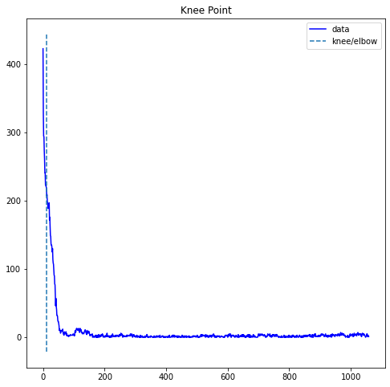

上述方法找到的拐点，是曲线变化最快的点。但是需要确定在哪个位置，视觉感知的联系降为最低（即特征点匹配的数量基本不再降低）的位置。这个位置是曲线变化基本为0的位置，就是计算每一点与前一点的差值，差值越小说明变化越小。如果这个差值变化基本保持不变，就说明已经找到了这个位置点，即保证差值的差值与前一差值保持相等。例如如果有一组数据为[20,10,8,1,1,1]，做第一次差值（取绝对值）结果为[10,2,7,0,0]，做差值的差值，结果为[8,5,7,0]，那么如果diff(x) == diff(diff(x))，即差值的差值第3个数7，与第一次差值的第3个数7相等，说明该位置之后曲线基本保持水平一致不再变化。同时满足diff(x) != 0，如果为0，即为数据相等，此时曲线已经保持基本不变。

下述图表绘制，对曲线做了平滑处理，降低噪声，以便找到跳变基本为0的位置点。同时，给出了置信区间，及标注异常点，便于观察数据平滑后的变化。平滑后的曲线尽量要在置信区间内，虽然在曲线降低的区段出现异常点，但是因为不在跳变稳定的区段，所以这个异常点错误对结果并没有影响。

import pandas as pd  
  
class movingAverage_inflection:   
 '''  
 class - 曲线（数据）平滑，与寻找曲线水平和纵向的斜率变化点  
   
 Params:  
 series - pandas 的Series格式数据  
 window - 滑动窗口大小，值越大，平滑程度越大  
 plot_intervals - 是否打印置信区间，某人为False   
 scale - 偏差比例，默认为1.96,   
 plot_anomalies - 是否打印异常值，默认为False,  
 figsize - 打印窗口大小，默认为(15,5),  
 threshold - 拐点阈值，默认为0  
 '''  
   
 def __init__(self,series, window, plot_intervals=False, scale=1.96, plot_anomalies=False,figsize=(15,5),threshold=0):  
 self.series=series  
 self.window=window  
 self.plot_intervals=plot_intervals  
 self.scale=scale  
 self.plot_anomalies=plot_anomalies  
 self.figsize=figsize  
   
 self.threshold=threshold  
 self.rolling_mean=self.movingAverage()  
   
 def masks(self,vec):  
 '''  
 function - 寻找曲线水平和纵向的斜率变化，参考 https://stackoverflow.com/questions/47342447/find-locations-on-a-curve-where-the-slope-changes  
 '''  
 d=np.diff(vec)  
 dd=np.diff(d)  
  
 # Mask of locations where graph goes to vertical or horizontal, depending on vec  
 to_mask=((d[:-1] != self.threshold) & (d[:-1] == -dd-self.threshold))  
 # Mask of locations where graph comes from vertical or horizontal, depending on vec  
 from_mask=((d[1:] != self.threshold) & (d[1:] == dd-self.threshold))  
 return to_mask, from_mask  
   
 def apply_mask(self,mask, x, y):  
 return x[1:-1][mask], y[1:-1][mask]   
   
 def knee_elbow(self):  
 '''  
 function - 返回拐点的起末位置  
 '''   
 x_r=np.array(self.rolling_mean.index)  
 y_r=np.array(self.rolling_mean)  
 to_vert_mask, from_vert_mask=self.masks(x_r)  
 to_horiz_mask, from_horiz_mask=self.masks(y_r)   
  
 to_vert_t, to_vert_v=self.apply_mask(to_vert_mask, x_r, y_r)  
 from_vert_t, from_vert_v=self.apply_mask(from_vert_mask, x_r, y_r)  
 to_horiz_t, to_horiz_v=self.apply_mask(to_horiz_mask, x_r, y_r)  
 from_horiz_t, from_horiz_v=self.apply_mask(from_horiz_mask, x_r, y_r)   
 return x_r,y_r,to_vert_t, to_vert_v,from_vert_t, from_vert_v,to_horiz_t, to_horiz_v,from_horiz_t, from_horiz_v  
  
 def movingAverage(self):  
 rolling_mean=self.series.rolling(window=self.window).mean()   
 return rolling_mean   
  
 def plot_movingAverage(self,inflection=False):  
 """  
 function - 打印移动平衡/滑动窗口，及拐点  
 """  
 import numpy as np  
 from sklearn.metrics import median_absolute_error, mean_absolute_error  
 import matplotlib.pyplot as plt   
  
 plt.figure(figsize=self.figsize)  
 plt.title("Moving average\n window size = {}".format(self.window))  
 plt.plot(self.rolling_mean, "g", label="Rolling mean trend")  
  
 # 打印置信区间，Plot confidence intervals for smoothed values  
 if self.plot_intervals:  
 mae=mean_absolute_error(self.series[self.window:], self.rolling_mean[self.window:])  
 deviation=np.std(self.series[self.window:] - self.rolling_mean[self.window:])  
 lower_bond=self.rolling_mean - (mae + self.scale * deviation)  
 upper_bond=self.rolling_mean + (mae + self.scale * deviation)  
 plt.plot(upper_bond, "r--", label="Upper Bond / Lower Bond")  
 plt.plot(lower_bond, "r--")  
  
 # 显示异常值，Having the intervals, find abnormal values  
 if self.plot_anomalies:  
 anomalies=pd.DataFrame(index=self.series.index, columns=self.series.to_frame().columns)  
 anomalies[self.series<lower_bond]=self.series[self.series<lower_bond].to_frame()  
 anomalies[self.series>upper_bond]=self.series[self.series>upper_bond].to_frame()  
 plt.plot(anomalies, "ro", markersize=10)  
   
 if inflection:  
 x_r,y_r,to_vert_t, to_vert_v,from_vert_t, from_vert_v,to_horiz_t, to_horiz_v,from_horiz_t, from_horiz_v=self.knee_elbow()  
 plt.plot(x_r, y_r, 'b-')  
 plt.plot(to_vert_t, to_vert_v, 'r^', label='Plot goes vertical')  
 plt.plot(from_vert_t, from_vert_v, 'kv', label='Plot stops being vertical')  
 plt.plot(to_horiz_t, to_horiz_v, 'r>', label='Plot goes horizontal')  
 plt.plot(from_horiz_t, from_horiz_v, 'k<', label='Plot stops being horizontal')   
   
  
 plt.plot(self.series[self.window:], label="Actual values")  
 plt.legend(loc="upper right")  
 plt.grid(True)  
 plt.xticks(rotation='vertical')  
 plt.show()  
  
  
import numpy as np  
import pandas as pd  
idx=0   
x=np.array(range(idx,idx+len(matches_num[idx])))   
y=np.array(matches_num[idx])  
y_=pd.Series(y,index=x)  
MAI=movingAverage_inflection(y_, window=15,plot_intervals=True,scale=1.96, plot_anomalies=True,figsize=(15*2,5*2),threshold=0)  
MAI.plot_movingAverage(inflection=True)

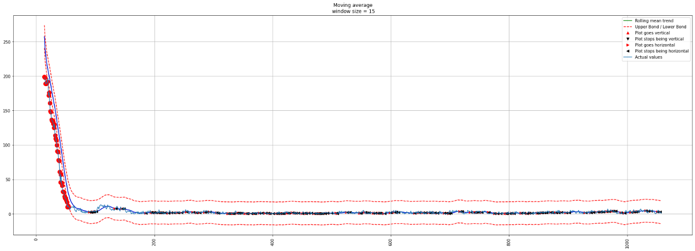

* C - 计算感知消失的距离

定位到第一个跳变为0的位置，就是曲线变化基本平缓的位置，获取其索引值。然后找出观察位置与第一个跳变为0位置之间所有图像的坐标，定义其为地理空间数据GeoDataFrame的数据格式。因为研究区域在德国，因此找到德国的EPSG编号，用于投影，然后计算路径的长度，并统计相关量。由结果可知，视觉感知消失距离的均值约为29m，16-46之间的数量约占到62%。

def vanishing_position_length(matches_num,coordi_df,epsg,**kwargs):  
 '''  
 function - 计算图像匹配特征点几乎无关联的距离，即对特定位置视觉随距离远去而感知消失的距离  
   
 Params:  
 matches_num - 由类dynamicStreetView_visualPerception计算的特征关键点匹配数量  
 coordi_df - 包含经纬度的DataFrame，其列名为：lon,lat  
 **kwargs - 同类movingAverage_inflection配置参数  
 '''  
 from shapely.geometry import Point, LineString, shape  
 import geopandas as gpd  
 import pyproj  
 import numpy as np   
   
 MAI_paras={'window':15,'plot_intervals':True,'scale':1.96, 'plot_anomalies':True,'figsize':(15*2,5*2),'threshold':0}  
 MAI_paras.update(kwargs)   
   
 vanishing_position={}  
 for idx in range(len(matches_num)):   
 x=np.array(range(idx,idx+len(matches_num[idx])))   
 y=np.array(matches_num[idx])  
 y_=pd.Series(y,index=x)   
 MAI=movingAverage_inflection(y_,   
 window=MAI_paras['window'],  
 plot_intervals=MAI_paras['plot_intervals'],  
 scale=MAI_paras['scale'],   
 plot_anomalies=MAI_paras['plot_anomalies'],  
 figsize=MAI_paras['figsize'],  
 threshold=MAI_paras['threshold'])   
 _,_,_,_,from_vert_t, _,_, _,from_horiz_t,_=MAI.knee_elbow()  
 if np.any(from_horiz_t!= None) :  
 vanishing_position[idx]=(idx,from_horiz_t[0])  
 else:  
 vanishing_position[idx]=(idx,idx)  
 vanishing_position_df=pd.DataFrame.from_dict(vanishing_position,orient='index',columns=['start_idx','end_idx'])  
  
 vanishing_position_df['geometry']=vanishing_position_df.apply(lambda idx:LineString(coordi_df[idx.start_idx:idx.end_idx][['lon','lat']].apply(lambda row:Point(row.lon,row.lat), axis=1).values.tolist()), axis=1)  
 crs_4326=4326  
 vanishing_position_gdf=gpd.GeoDataFrame(vanishing_position_df,geometry='geometry',crs=crs_4326)  
   
 crs_=pyproj.CRS(epsg)   
 vanishing_position_gdf_reproj=vanishing_position_gdf.to_crs(crs_)  
 vanishing_position_gdf_reproj['length']=vanishing_position_gdf_reproj.geometry.length  
   
 return vanishing_position_gdf_reproj  
   
   
coordi_df=drive_29_0071_info  
vanishing_gpd=vanishing_position_length(matches_num,coordi_df,epsg="EPSG:3857",threshold=0)  
print("感知消失距离统计:","_"*50,"\n")  
print(vanishing_gpd[vanishing_gpd["length"] >1].length.describe())  
print("频数统计：","_"*50,"\n")  
print(vanishing_gpd[vanishing_gpd["length"] >1]["length"].value_counts(bins=5))  
  
util_misc.print_html(vanishing_gpd)

感知消失距离统计: __________________________________________________   
  
count 1000.000000  
mean 9472.084030  
std 3682.111894  
min 1686.790065  
25% 6785.848838  
50% 9019.067193  
75% 11666.403897  
max 25517.460098  
dtype: float64  
频数统计： __________________________________________________   
  
(6452.924, 11219.058] 513  
(11219.058, 15985.192] 221  
(1662.958, 6452.924] 202  
(15985.192, 20751.326] 52  
(20751.326, 25517.46] 12  
Name: length, dtype: int64

|  | **start_idx** | **end_idx** | **geometry** | **length** |
| --- | --- | --- | --- | --- |
| **0** | 0 | 91 | LINESTRING (934871.288 6276329.185, 934817.770 6276350.782, 934698.648 6276416.118, 934758.123 6276382.241, 934555.096 6276474.385, 934582.633 6276462.571, 934820.487 6276349.552, 934689.196 6276418.556, 934666.822 6276423.977, 934647.274 6276432.031, 934807.511 6276356.534, 934632.396 6276439.052, 934645.552 6276432.798, 934793.653 6276364.935, 934669.321 6276422.763, 934669.615 6276422.708, 934618.726 6276445.415, 934690.507 6276418.043, 934849.178 6276338.450, 934555.859 6276477.946, 934562.444 6276472.854, 934864.587 6276332.052, 934555.629 6276477.202, 934658.646 6276427.226, 934646.120 6276432.545, 934794.678 6276364.440, 934686.252 6276418.903, 934812.914 6276353.022, 934633.218 6276438.645, 934558.845 6276475.277, 934590.461 6276458.855, 934774.093 6276374.246, 934555.549 6276476.888, 934680.325 6276421.361, 934667.992 6276423.367, 934754.611 6276385.202, 934666.521 6276424.131, 934665.058 6276424.796, 934556.394 6276477.382, 934641.811 6276434.507, 934762.456 6276379.919, 934558.361 6276475.849, 934554.986 6276475.778, 934856.654 6276335.123, 934672.059 6276424.474, 934712.390 6276410.633, 934745.563 6276392.332, 934680.841 6276421.068, 934855.182 6276335.798, 934699.053 6276416.000, 934763.118 6276379.589, 934871.774 6276328.932, 934718.907 6276407.240, 934561.693 6276473.287, 934679.239 6276421.599, 934566.357 6276470.793, 934681.199 6276420.995, 934670.015 6276424.164, 934691.734 6276416.951, 934557.752 6276476.360, 934844.122 6276340.414, 934676.161 6276422.458, 934808.727 6276355.469, 934555.157 6276475.937, 934558.862 6276475.244, 934555.504 6276476.723, 934555.909 6276477.868, 934835.694 6276343.398, 934737.546 6276397.986, 934656.424 6276428.022, 934556.936 6276476.978, 934555.224 6276476.003, 934586.408 6276460.755, 934791.945 6276365.762, 934837.420 6276342.772, 934674.240 6276423.492, 934799.567 6276361.996, 934641.123 6276434.820, 934682.254 6276420.564, 934702.190 6276415.665, 934555.957 6276478.035, 934555.457 6276476.526, 934757.094 6276383.063, 934840.246 6276341.760, 934760.180 6276381.019, 934668.238 6276423.249, 934850.254 6276337.997, 934661.470 6276426.226, 934555.210 6276475.983, 934757.367 6276382.842, 934669.736 6276423.001) | 11310.685843 |
| **1** | 1 | 81 | LINESTRING (934817.770 6276350.782, 934698.648 6276416.118, 934758.123 6276382.241, 934555.096 6276474.385, 934582.633 6276462.571, 934820.487 6276349.552, 934689.196 6276418.556, 934666.822 6276423.977, 934647.274 6276432.031, 934807.511 6276356.534, 934632.396 6276439.052, 934645.552 6276432.798, 934793.653 6276364.935, 934669.321 6276422.763, 934669.615 6276422.708, 934618.726 6276445.415, 934690.507 6276418.043, 934849.178 6276338.450, 934555.859 6276477.946, 934562.444 6276472.854, 934864.587 6276332.052, 934555.629 6276477.202, 934658.646 6276427.226, 934646.120 6276432.545, 934794.678 6276364.440, 934686.252 6276418.903, 934812.914 6276353.022, 934633.218 6276438.645, 934558.845 6276475.277, 934590.461 6276458.855, 934774.093 6276374.246, 934555.549 6276476.888, 934680.325 6276421.361, 934667.992 6276423.367, 934754.611 6276385.202, 934666.521 6276424.131, 934665.058 6276424.796, 934556.394 6276477.382, 934641.811 6276434.507, 934762.456 6276379.919, 934558.361 6276475.849, 934554.986 6276475.778, 934856.654 6276335.123, 934672.059 6276424.474, 934712.390 6276410.633, 934745.563 6276392.332, 934680.841 6276421.068, 934855.182 6276335.798, 934699.053 6276416.000, 934763.118 6276379.589, 934871.774 6276328.932, 934718.907 6276407.240, 934561.693 6276473.287, 934679.239 6276421.599, 934566.357 6276470.793, 934681.199 6276420.995, 934670.015 6276424.164, 934691.734 6276416.951, 934557.752 6276476.360, 934844.122 6276340.414, 934676.161 6276422.458, 934808.727 6276355.469, 934555.157 6276475.937, 934558.862 6276475.244, 934555.504 6276476.723, 934555.909 6276477.868, 934835.694 6276343.398, 934737.546 6276397.986, 934656.424 6276428.022, 934556.936 6276476.978, 934555.224 6276476.003, 934586.408 6276460.755, 934791.945 6276365.762, 934837.420 6276342.772, 934674.240 6276423.492, 934799.567 6276361.996, 934641.123 6276434.820, 934682.254 6276420.564, 934702.190 6276415.665, 934555.957 6276478.035) | 9900.262438 |
| **2** | 2 | 81 | LINESTRING (934698.648 6276416.118, 934758.123 6276382.241, 934555.096 6276474.385, 934582.633 6276462.571, 934820.487 6276349.552, 934689.196 6276418.556, 934666.822 6276423.977, 934647.274 6276432.031, 934807.511 6276356.534, 934632.396 6276439.052, 934645.552 6276432.798, 934793.653 6276364.935, 934669.321 6276422.763, 934669.615 6276422.708, 934618.726 6276445.415, 934690.507 6276418.043, 934849.178 6276338.450, 934555.859 6276477.946, 934562.444 6276472.854, 934864.587 6276332.052, 934555.629 6276477.202, 934658.646 6276427.226, 934646.120 6276432.545, 934794.678 6276364.440, 934686.252 6276418.903, 934812.914 6276353.022, 934633.218 6276438.645, 934558.845 6276475.277, 934590.461 6276458.855, 934774.093 6276374.246, 934555.549 6276476.888, 934680.325 6276421.361, 934667.992 6276423.367, 934754.611 6276385.202, 934666.521 6276424.131, 934665.058 6276424.796, 934556.394 6276477.382, 934641.811 6276434.507, 934762.456 6276379.919, 934558.361 6276475.849, 934554.986 6276475.778, 934856.654 6276335.123, 934672.059 6276424.474, 934712.390 6276410.633, 934745.563 6276392.332, 934680.841 6276421.068, 934855.182 6276335.798, 934699.053 6276416.000, 934763.118 6276379.589, 934871.774 6276328.932, 934718.907 6276407.240, 934561.693 6276473.287, 934679.239 6276421.599, 934566.357 6276470.793, 934681.199 6276420.995, 934670.015 6276424.164, 934691.734 6276416.951, 934557.752 6276476.360, 934844.122 6276340.414, 934676.161 6276422.458, 934808.727 6276355.469, 934555.157 6276475.937, 934558.862 6276475.244, 934555.504 6276476.723, 934555.909 6276477.868, 934835.694 6276343.398, 934737.546 6276397.986, 934656.424 6276428.022, 934556.936 6276476.978, 934555.224 6276476.003, 934586.408 6276460.755, 934791.945 6276365.762, 934837.420 6276342.772, 934674.240 6276423.492, 934799.567 6276361.996, 934641.123 6276434.820, 934682.254 6276420.564, 934702.190 6276415.665, 934555.957 6276478.035) | 9764.399529 |
| **3** | 3 | 81 | LINESTRING (934758.123 6276382.241, 934555.096 6276474.385, 934582.633 6276462.571, 934820.487 6276349.552, 934689.196 6276418.556, 934666.822 6276423.977, 934647.274 6276432.031, 934807.511 6276356.534, 934632.396 6276439.052, 934645.552 6276432.798, 934793.653 6276364.935, 934669.321 6276422.763, 934669.615 6276422.708, 934618.726 6276445.415, 934690.507 6276418.043, 934849.178 6276338.450, 934555.859 6276477.946, 934562.444 6276472.854, 934864.587 6276332.052, 934555.629 6276477.202, 934658.646 6276427.226, 934646.120 6276432.545, 934794.678 6276364.440, 934686.252 6276418.903, 934812.914 6276353.022, 934633.218 6276438.645, 934558.845 6276475.277, 934590.461 6276458.855, 934774.093 6276374.246, 934555.549 6276476.888, 934680.325 6276421.361, 934667.992 6276423.367, 934754.611 6276385.202, 934666.521 6276424.131, 934665.058 6276424.796, 934556.394 6276477.382, 934641.811 6276434.507, 934762.456 6276379.919, 934558.361 6276475.849, 934554.986 6276475.778, 934856.654 6276335.123, 934672.059 6276424.474, 934712.390 6276410.633, 934745.563 6276392.332, 934680.841 6276421.068, 934855.182 6276335.798, 934699.053 6276416.000, 934763.118 6276379.589, 934871.774 6276328.932, 934718.907 6276407.240, 934561.693 6276473.287, 934679.239 6276421.599, 934566.357 6276470.793, 934681.199 6276420.995, 934670.015 6276424.164, 934691.734 6276416.951, 934557.752 6276476.360, 934844.122 6276340.414, 934676.161 6276422.458, 934808.727 6276355.469, 934555.157 6276475.937, 934558.862 6276475.244, 934555.504 6276476.723, 934555.909 6276477.868, 934835.694 6276343.398, 934737.546 6276397.986, 934656.424 6276428.022, 934556.936 6276476.978, 934555.224 6276476.003, 934586.408 6276460.755, 934791.945 6276365.762, 934837.420 6276342.772, 934674.240 6276423.492, 934799.567 6276361.996, 934641.123 6276434.820, 934682.254 6276420.564, 934702.190 6276415.665, 934555.957 6276478.035) | 9695.952996 |
| **4** | 4 | 82 | LINESTRING (934555.096 6276474.385, 934582.633 6276462.571, 934820.487 6276349.552, 934689.196 6276418.556, 934666.822 6276423.977, 934647.274 6276432.031, 934807.511 6276356.534, 934632.396 6276439.052, 934645.552 6276432.798, 934793.653 6276364.935, 934669.321 6276422.763, 934669.615 6276422.708, 934618.726 6276445.415, 934690.507 6276418.043, 934849.178 6276338.450, 934555.859 6276477.946, 934562.444 6276472.854, 934864.587 6276332.052, 934555.629 6276477.202, 934658.646 6276427.226, 934646.120 6276432.545, 934794.678 6276364.440, 934686.252 6276418.903, 934812.914 6276353.022, 934633.218 6276438.645, 934558.845 6276475.277, 934590.461 6276458.855, 934774.093 6276374.246, 934555.549 6276476.888, 934680.325 6276421.361, 934667.992 6276423.367, 934754.611 6276385.202, 934666.521 6276424.131, 934665.058 6276424.796, 934556.394 6276477.382, 934641.811 6276434.507, 934762.456 6276379.919, 934558.361 6276475.849, 934554.986 6276475.778, 934856.654 6276335.123, 934672.059 6276424.474, 934712.390 6276410.633, 934745.563 6276392.332, 934680.841 6276421.068, 934855.182 6276335.798, 934699.053 6276416.000, 934763.118 6276379.589, 934871.774 6276328.932, 934718.907 6276407.240, 934561.693 6276473.287, 934679.239 6276421.599, 934566.357 6276470.793, 934681.199 6276420.995, 934670.015 6276424.164, 934691.734 6276416.951, 934557.752 6276476.360, 934844.122 6276340.414, 934676.161 6276422.458, 934808.727 6276355.469, 934555.157 6276475.937, 934558.862 6276475.244, 934555.504 6276476.723, 934555.909 6276477.868, 934835.694 6276343.398, 934737.546 6276397.986, 934656.424 6276428.022, 934556.936 6276476.978, 934555.224 6276476.003, 934586.408 6276460.755, 934791.945 6276365.762, 934837.420 6276342.772, 934674.240 6276423.492, 934799.567 6276361.996, 934641.123 6276434.820, 934682.254 6276420.564, 934702.190 6276415.665, 934555.957 6276478.035, 934555.457 6276476.526) | 9474.584042 |

import matplotlib.pyplot as plt  
import matplotlib.image as mpimg  
  
fig, axs=plt.subplots(ncols=2,nrows=1,figsize =(30, 15))  
starting_idx=vanishing_gpd.iloc[0].start_idx  
ending_idx=vanishing_gpd.iloc[0].end_idx  
axs[0].imshow(mpimg.imread(drive_29_0071_img_fp_list[starting_idx]))  
axs[0].set_title("starting position ")  
axs[1].imshow(mpimg.imread(drive_29_0071_img_fp_list[ending_idx]))  
axs[1].set_title("ending position ")  
  
plt.show()

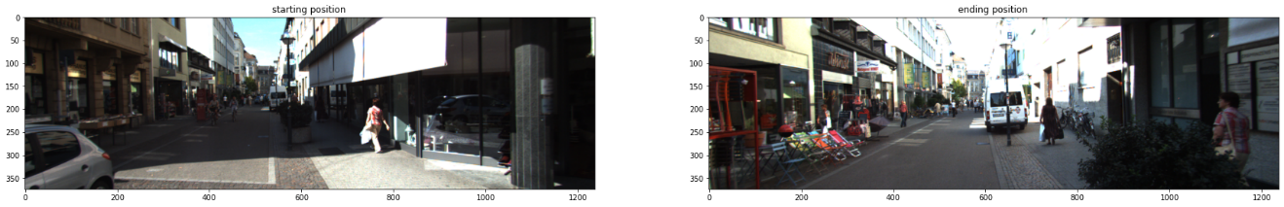

FLANN_INDEX_KDTREE = 1  
im_1,im_2=drive_29_0071_img_fp_list[starting_idx],drive_29_0071_img_fp_list[ending_idx]  
index_params=dict(algorithm=FLANN_INDEX_KDTREE, trees=5)   
feature_matching(im_1,im_2,index_params=index_params,method='FLANN',)

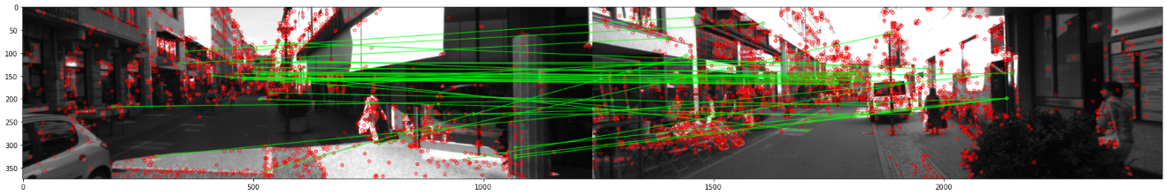

* D - 比较两个街区的变化

与上述方法相同，选取了自然景观偏多的另一个街区。比较计算结果为：

| 统计量 | 街区_26_0009 | 街区_29_0071 |
| --- | --- | --- |
| count | 983 | 388 |
| mean | 29.147147 | 64.207892 |
| std | 15.663416 | 32.833346 |
| min | 1.034268 | 1.065737 |
| 25% | 18.190853 | 42.206708 |
| 50% | 29.592061 | 61.216303 |
| 75% | 40.271488 | 84.249092 |
| max | 76.957715 | 190.549947 |

从计算的结果可以观察到，不同的街区视觉感知消失的距离不同。城市内的街道小巷视觉感知消失的距离较之较为开阔自然植被相对较多的街道要小，标准差也偏小，即分布的离散程度要小。就是说，在变化丰富的小巷中行走时，视觉感知变化会比较快，有琳琅满目的感觉；但是在开阔区域行走时，视觉感知变化就会很慢，这里是慢了约2倍的距离。当然对于同是小巷而言，不同的设计，这个视觉变化也会不同，例如推断景观单一的小巷，视觉感知变化应该比较慢，注意这里并没有数据计算验证。

KITTI_info_fp=r'F:\data\2011_09_26_drive_0009_sync\oxts\data'  
timestamps_fp=r'F:\data\2011_09_26_drive_0009_sync\image_03\timestamps.txt'  
drive_26_0009_info=KITTI_info(KITTI_info_fp,timestamps_fp)  
drive_26_0009_info.sort_values(by="timestamps_",inplace=True)   
util_misc.print_html(drive_26_0009_info)

|  | **index** | **lat** | **lon** | **alt** | **roll** | **pitch** | **yaw** | **vn** | **ve** | **vf** | **vl** | **vu** | **ax** | **ay** | **ay** | **af** | **al** | **au** | **wx** | **wy** | **wz** | **wf** | **wl** | **wu** | **pos_accuracy** | **vel_accuracy** | **navstat** | **numsats** | **posmode** | **velmode** | **orimode** | **timestamps_** |
| --- | --- | --- | --- | --- | --- | --- | --- | --- | --- | --- | --- | --- | --- | --- | --- | --- | --- | --- | --- | --- | --- | --- | --- | --- | --- | --- | --- | --- | --- | --- | --- | --- |
| **0** | 0 | 49.009301 | 8.437381 | 114.422829 | 0.069594 | 0.010577 | -0.267587 | -2.840424 | 9.984114 | 10.379826 | 0.098710 | -0.056643 | -0.507791 | 0.613263 | 9.688881 | -0.407213 | -0.048290 | 9.713059 | 0.024659 | 0.003836 | 0.001496 | 0.024676 | 0.003726 | 0.001491 | 0.459027 | 0.063655 | 4.0 | 8.0 | 4.0 | 4.0 | 0.0 | 2011-09-26 13:08:24.967313152 |
| **1** | 0 | 49.008928 | 8.439355 | 114.427513 | 0.043021 | 0.013709 | -0.303302 | -2.324740 | 7.397596 | 7.754275 | 0.014234 | -0.024675 | -1.719590 | 0.171898 | 9.812524 | -1.590278 | -0.243565 | 9.832890 | 0.012255 | 0.009080 | -0.011605 | 0.012107 | 0.009564 | -0.011381 | 0.441808 | 0.045255 | 4.0 | 9.0 | 4.0 | 4.0 | 0.0 | 2011-09-26 13:08:25.070703872 |
| **2** | 0 | 49.009635 | 8.440149 | 114.995842 | 0.017513 | 0.009770 | 1.109966 | 8.693748 | 4.271207 | 9.686266 | -0.029648 | -0.002070 | -0.501934 | -0.059005 | 9.688035 | -0.407256 | -0.221883 | 9.690147 | 0.012669 | -0.000569 | -0.019645 | 0.012477 | -0.000239 | -0.019776 | 0.394154 | 0.014866 | 4.0 | 8.0 | 5.0 | 5.0 | 0.0 | 2011-09-26 13:08:25.174198784 |
| **3** | 0 | 49.008939 | 8.439300 | 114.467484 | 0.043166 | 0.015248 | -0.295857 | -2.485433 | 8.144280 | 8.515079 | 0.012665 | -0.067607 | -1.430890 | 0.310727 | 9.701541 | -1.279239 | -0.107750 | 9.727096 | 0.001244 | -0.007206 | -0.019501 | 0.000935 | -0.006359 | -0.019811 | 0.434815 | 0.039598 | 4.0 | 8.0 | 4.0 | 4.0 | 0.0 | 2011-09-26 13:08:25.277587456 |
| **4** | 0 | 49.008892 | 8.439517 | 114.440964 | 0.046248 | 0.014093 | -0.345967 | -1.440422 | 4.004494 | 4.255673 | 0.000746 | -0.034648 | -1.578798 | 0.601459 | 9.761063 | -1.439248 | 0.139238 | 9.800171 | -0.018784 | -0.003619 | -0.014698 | -0.018993 | -0.002919 | -0.014575 | 0.464802 | 0.053038 | 4.0 | 10.0 | 4.0 | 4.0 | 0.0 | 2011-09-26 13:08:25.381086208 |

drive_26_0009_info.sort_values(by="timestamps_",inplace=True)  
plotly_scatterMapbox(drive_26_0009_info,center_lon=8.437134,center_lat=49.009348)

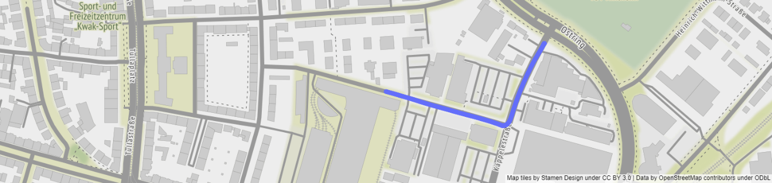

import util_misc,os  
drive_26_0009_img_fp=util_misc.filePath_extraction(r'F:\data\2011_09_26_drive_0009_sync\image_03\data',['png'])  
drive_26_0009_img_fp_list=util_misc.flatten_lst([[os.path.join(k,f) for f in drive_26_0009_img_fp[k]] for k,v in drive_26_0009_img_fp.items()])  
drive_26_0009_img_fp_list.sort()

import matplotlib.pyplot as plt  
import matplotlib.animation as animation  
import matplotlib.image as mpimg  
from IPython.display import HTML  
  
fig=plt.figure(figsize=(20,10))  
ims=[[plt.imshow(mpimg.imread(f),animated=True)] for f in drive_26_0009_img_fp_list] #[:200]  
print("finished reading the imgs.")  
  
ani=animation.ArtistAnimation(fig, ims, interval=100, blit=True,repeat_delay=1000)  
# ani.save(r'./imgs/drive_26_0009_info.mp4')  
# print(".mp4 saved.")  
HTML(ani.to_html5_video())

finished reading the imgs.

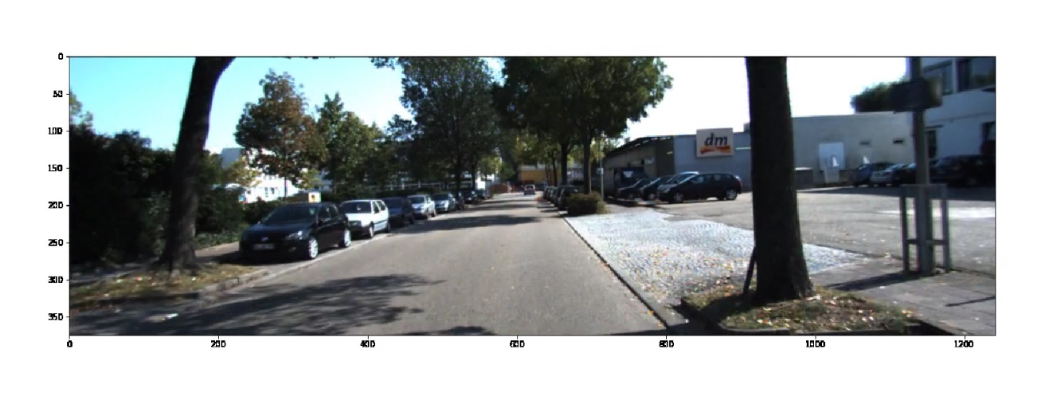

dsv_vp_=dynamicStreetView_visualPerception(drive_26_0009_img_fp_list)   
# kp1,des1=dsv_vp.kp_descriptor(drive_29_0071_img_fp_list[10])   
# kp2,des2=dsv_vp.kp_descriptor(drive_29_0071_img_fp_list[50])  
# dsv_vp.feature_matching(des1,des2,kp1,kp2)  
matches_num_=dsv_vp_.sequence_statistics()

计算关键点和描述子...  
  
  
100%|██████████| 447/447 [00:30<00:00, 14.71it/s]  
  
  
计算序列图像匹配数...  
  
  
100%|██████████| 446/446 [04:41<00:00, 1.58it/s]

import numpy as np  
import pandas as pd  
idx=0   
x=np.array(range(idx,idx+len(matches_num_[idx])))   
y=np.array(matches_num_[idx])  
y_=pd.Series(y,index=x)  
MAI_=movingAverage_inflection(y_, window=15,plot_intervals=True,scale=1.96, plot_anomalies=True,figsize=(15*2,5*2),threshold=0)  
MAI_.plot_movingAverage(inflection=True)

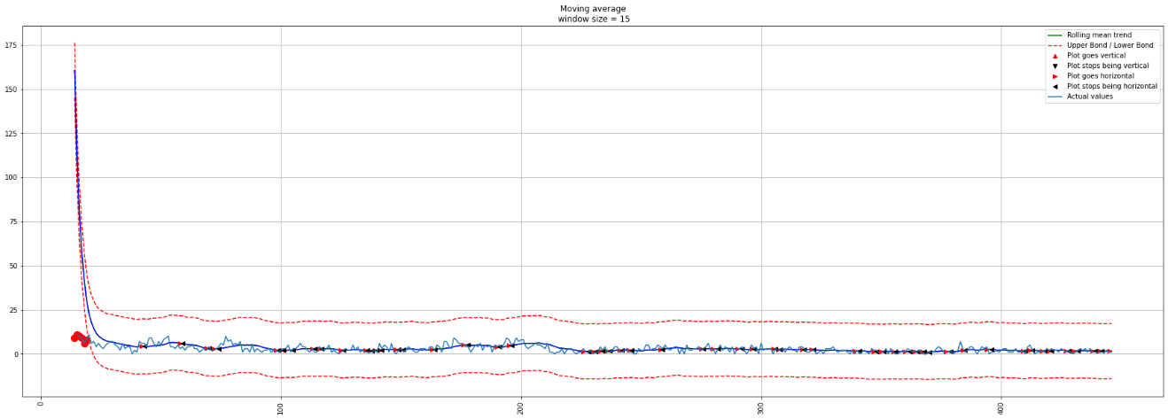

coordi_df_=drive_26_0009_info  
vanishing_gpd_=vanishing_position_length(matches_num_,coordi_df_,epsg="EPSG:3857",threshold=0)  
print("感知消失距离统计:","_"*50,"\n")  
print(vanishing_gpd_[vanishing_gpd_["length"] >1].length.describe())  
print("频数统计：","_"*50,"\n")  
print(vanishing_gpd_[vanishing_gpd_["length"] >1]["length"].value_counts(bins=5))  
  
util_misc.print_html(vanishing_gpd_)

C:\Users\richi\anaconda3\envs\USDA_database\lib\site-packages\pandas\core\dtypes\cast.py:91: ShapelyDeprecationWarning:  
  
The array interface is deprecated and will no longer work in Shapely 2.0. Convert the '.coords' to a numpy array instead.

​

感知消失距离统计: __________________________________________________   
  
count 394.000000  
mean 8204.107097  
std 2568.032994  
min 3416.112516  
25% 6258.602582  
50% 7925.625998  
75% 9579.572420  
max 18884.995266  
dtype: float64  
频数统计： __________________________________________________   
  
(6509.889, 9603.666] 185  
(3400.6429999999996, 6509.889] 111  
(9603.666, 12697.442] 69  
(12697.442, 15791.219] 27  
(15791.219, 18884.995] 2  
Name: length, dtype: int64

|  | **start_idx** | **end_idx** | **geometry** | **length** |
| --- | --- | --- | --- | --- |
| **0** | 0 | 43 | LINESTRING (939244.958 6276439.793, 939464.656 6276376.477, 939553.124 6276496.368, 939458.572 6276378.369, 939482.745 6276370.323, 939495.218 6276367.618, 939353.558 6276407.580, 939286.066 6276427.547, 939493.893 6276367.356, 939473.818 6276373.537, 939521.797 6276420.909, 939577.487 6276540.775, 939539.882 6276467.490, 939312.718 6276419.149, 939588.272 6276559.968, 939317.740 6276417.634, 939538.584 6276464.477, 939232.286 6276443.526, 939392.536 6276396.677, 939480.834 6276371.110, 939418.762 6276389.752, 939588.652 6276560.435, 939497.736 6276368.520, 939413.954 6276390.965, 939490.101 6276367.650, 939561.119 6276512.361, 939405.847 6276393.101, 939544.425 6276477.783, 939339.748 6276411.426, 939559.116 6276508.464, 939488.277 6276368.208, 939493.093 6276367.286, 939290.989 6276425.912, 939341.565 6276410.915, 939489.483 6276367.823, 939358.691 6276406.175, 939457.335 6276378.747, 939588.584 6276560.429, 939492.750 6276367.264, 939588.630 6276560.602, 939501.696 6276371.117, 939370.644 6276402.799, 939558.467 6276507.196) | 6633.560308 |
| **1** | 1 | 40 | LINESTRING (939464.656 6276376.477, 939553.124 6276496.368, 939458.572 6276378.369, 939482.745 6276370.323, 939495.218 6276367.618, 939353.558 6276407.580, 939286.066 6276427.547, 939493.893 6276367.356, 939473.818 6276373.537, 939521.797 6276420.909, 939577.487 6276540.775, 939539.882 6276467.490, 939312.718 6276419.149, 939588.272 6276559.968, 939317.740 6276417.634, 939538.584 6276464.477, 939232.286 6276443.526, 939392.536 6276396.677, 939480.834 6276371.110, 939418.762 6276389.752, 939588.652 6276560.435, 939497.736 6276368.520, 939413.954 6276390.965, 939490.101 6276367.650, 939561.119 6276512.361, 939405.847 6276393.101, 939544.425 6276477.783, 939339.748 6276411.426, 939559.116 6276508.464, 939488.277 6276368.208, 939493.093 6276367.286, 939290.989 6276425.912, 939341.565 6276410.915, 939489.483 6276367.823, 939358.691 6276406.175, 939457.335 6276378.747, 939588.584 6276560.429, 939492.750 6276367.264, 939588.630 6276560.602) | 5846.731901 |
| **2** | 2 | 59 | LINESTRING (939553.124 6276496.368, 939458.572 6276378.369, 939482.745 6276370.323, 939495.218 6276367.618, 939353.558 6276407.580, 939286.066 6276427.547, 939493.893 6276367.356, 939473.818 6276373.537, 939521.797 6276420.909, 939577.487 6276540.775, 939539.882 6276467.490, 939312.718 6276419.149, 939588.272 6276559.968, 939317.740 6276417.634, 939538.584 6276464.477, 939232.286 6276443.526, 939392.536 6276396.677, 939480.834 6276371.110, 939418.762 6276389.752, 939588.652 6276560.435, 939497.736 6276368.520, 939413.954 6276390.965, 939490.101 6276367.650, 939561.119 6276512.361, 939405.847 6276393.101, 939544.425 6276477.783, 939339.748 6276411.426, 939559.116 6276508.464, 939488.277 6276368.208, 939493.093 6276367.286, 939290.989 6276425.912, 939341.565 6276410.915, 939489.483 6276367.823, 939358.691 6276406.175, 939457.335 6276378.747, 939588.584 6276560.429, 939492.750 6276367.264, 939588.630 6276560.602, 939501.696 6276371.117, 939370.644 6276402.799, 939558.467 6276507.196, 939449.222 6276381.188, 939586.730 6276557.301, 939563.145 6276516.181, 939562.490 6276514.958, 939549.762 6276489.342, 939363.791 6276404.762, 939570.036 6276528.349, 939492.421 6276367.279, 939522.785 6276423.764, 939588.650 6276560.448, 939509.865 6276384.286, 939586.051 6276556.054, 939410.695 6276391.824, 939510.676 6276386.508, 939412.247 6276391.427, 939319.370 6276417.146) | 8479.098560 |
| **3** | 3 | 36 | LINESTRING (939458.572 6276378.369, 939482.745 6276370.323, 939495.218 6276367.618, 939353.558 6276407.580, 939286.066 6276427.547, 939493.893 6276367.356, 939473.818 6276373.537, 939521.797 6276420.909, 939577.487 6276540.775, 939539.882 6276467.490, 939312.718 6276419.149, 939588.272 6276559.968, 939317.740 6276417.634, 939538.584 6276464.477, 939232.286 6276443.526, 939392.536 6276396.677, 939480.834 6276371.110, 939418.762 6276389.752, 939588.652 6276560.435, 939497.736 6276368.520, 939413.954 6276390.965, 939490.101 6276367.650, 939561.119 6276512.361, 939405.847 6276393.101, 939544.425 6276477.783, 939339.748 6276411.426, 939559.116 6276508.464, 939488.277 6276368.208, 939493.093 6276367.286, 939290.989 6276425.912, 939341.565 6276410.915, 939489.483 6276367.823, 939358.691 6276406.175) | 4788.573259 |
| **4** | 4 | 37 | LINESTRING (939482.745 6276370.323, 939495.218 6276367.618, 939353.558 6276407.580, 939286.066 6276427.547, 939493.893 6276367.356, 939473.818 6276373.537, 939521.797 6276420.909, 939577.487 6276540.775, 939539.882 6276467.490, 939312.718 6276419.149, 939588.272 6276559.968, 939317.740 6276417.634, 939538.584 6276464.477, 939232.286 6276443.526, 939392.536 6276396.677, 939480.834 6276371.110, 939418.762 6276389.752, 939588.652 6276560.435, 939497.736 6276368.520, 939413.954 6276390.965, 939490.101 6276367.650, 939561.119 6276512.361, 939405.847 6276393.101, 939544.425 6276477.783, 939339.748 6276411.426, 939559.116 6276508.464, 939488.277 6276368.208, 939493.093 6276367.286, 939290.989 6276425.912, 939341.565 6276410.915, 939489.483 6276367.823, 939358.691 6276406.175, 939457.335 6276378.747) | 4865.482065 |

import matplotlib.pyplot as plt  
import matplotlib.image as mpimg  
  
idx_=30  
fig, axs=plt.subplots(ncols=2,nrows=1,figsize =(30, 15))  
starting_idx_=vanishing_gpd_.iloc[idx_].start_idx  
ending_idx_=vanishing_gpd_.iloc[idx_].end_idx  
axs[0].imshow(mpimg.imread(drive_26_0009_img_fp_list[starting_idx_]))  
axs[0].set_title("starting position ")  
axs[1].imshow(mpimg.imread(drive_26_0009_img_fp_list[ending_idx_]))  
axs[1].set_title("ending position ")  
  
plt.show()

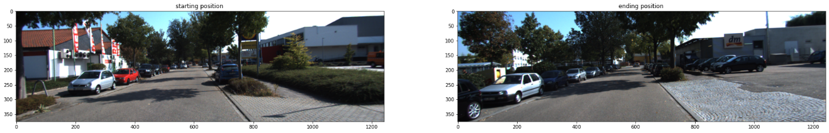

FLANN_INDEX_KDTREE = 1  
im_1_,im_2_=drive_26_0009_img_fp_list[starting_idx_],drive_26_0009_img_fp_list[ending_idx_]  
index_params=dict(algorithm=FLANN_INDEX_KDTREE, trees=5)   
feature_matching(im_1_,im_2_,index_params=index_params,method='FLANN',)

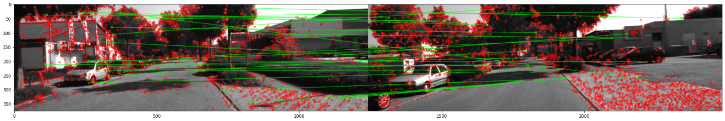

注释（Notes）：

① OpenCV，是一个开源的计算机视觉和机器学习软件库。该库有超过2500种优化算法，其中包括一套全面的经典和最先进的计算机视觉和机器学习算法。这些算法可用于检测和识别人脸、识别物体、对视频中的人类行为进行分类、跟踪摄像机运动、跟踪移动物体、提取物体的三维模型、从立体摄像机中产生三维点云、将图像拼接起来以产生整个场景的高分辨率图像、从图像数据库中寻找相似的图像、从使用闪光灯拍摄的图像中去除红眼、跟踪眼睛运动、识别景物并建立标记以与增强现实叠加等。（<https://opencv.org/>）。

② OpenCV-Python，OpenCV的Python实现库（<https://docs.opencv.org/4.x/d6/d00/tutorial_py_root.html>）。

③ OpenCV提供了三种方式，特征匹配（<https://docs.opencv.org/4.x/dc/dc3/tutorial_py_matcher.html>）。

④ The KITTI Vision Benchmark Suite，利用无人驾驶平台Annieway开发具有挑战性的现实世界计算机视觉基准（computer vision benchmarks）（<https://www.cvlibs.net/datasets/kitti/index.php>）。

⑤ 2011_09_29_drive_0071 (4.1 GB)，数据下载地址（<https://www.cvlibs.net/datasets/kitti/raw_data.php>）。

参考文献（References）:

[1] D.Lowe.Distinctive Image Features from Scale-Invariant Keypoints[J], 2004. （SIFT提出者）